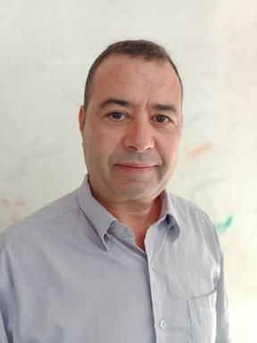 Abdelkarim Assoul Assoul Abdelkarim .Graduate Diploma in MathematicsTeacher Trainer of Mathematics in High School-tutoring

Identifiants chercheurs

- IdHAL : abdelkarim-assoul
- ORCID : 0000-0002-1015-7250
- ResearcherID : http://www.researcherid.com/rid/X-5356-2018

Présentation

Publications

Pré-publication, Document de travail (2)

The application of the hypercomplex number in a three dimensional space in quantum computing
Abdelkarim Assoul
2018
Pré-publication, Document de travail
hal-01930431v1
The sum of the natural numbers peers, odd of p th degree
Abdelkarim Assoul
2015
Pré-publication, Document de travail
hal-01924427v1

