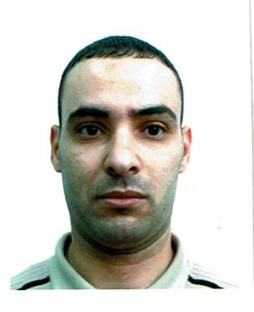 Abdelkrim Meziani

Identifiants chercheurs

- IdHAL : abdelkrim-meziani
- ORCID : 0009-0003-1849-4985

Présentation

I am a dedicated Python programmer and independent researcher with a deep passion for deconstructing complex problems and efficient algorithmic solutions. My work sits at the intersection of theoretical computer science and practical application, where I focus on developing and optimizing algorithms for real-world challenges.
I am also an experienced educator, committed to demystifying the fields of programming and algorithmic thinking for students and professionals alike. I believe in empowering others with the skills to solve problems creatively and effectively.

Publications

