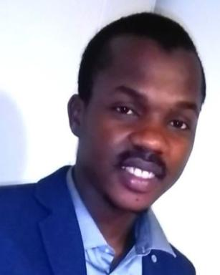 Abdou DIA Enseignant-Chercheur,ESTP

Identifiants chercheurs

- IdHAL : abdou-dia
- ORCID : 0000-0001-6551-9856

Publications

Article dans une revue (2)

Vibration-Based Non-Destructive Techniques for a 3-Level Characterization of Damages in Cables
Abdou Dia,Lamine Dieng,Laurent Gaillet
Conference Proceedings of the Society for Experimental Mechanics Series, 2021, Conference Proceedings of the Society for Experimental Mechanics Series, 5, pp.165-172. ⟨10.1007/978-3-030-47709-7_16⟩
Article dans une revue
hal-04320406v1
Damage detection of a hybrid composite laminate aluminum/glass under quasi-static and fatigue loadings by acoustic emission technique
Abdou Dia,Lamine Dieng,Laurent Gaillet,Papa Birame Gning
Heliyon, 2019, 5 (3), pp.e01414. ⟨10.1016/j.heliyon.2019.e01414⟩
Article dans une revue
hal-04320455v1

Chapitre d'ouvrage (3)

Comparison of modal parametric and nonparametric vibration-based techniques
A. Dia,N. Makhoul
Bridge Maintenance, Safety, Management, Digitalization and Sustainability, 1, CRC Press, pp.769-776, 2024, ⟨10.1201/9781003483755-89⟩
Chapitre d'ouvrage
hal-05038578v1
Life Cycle Assessment of a Smart Building: Energy Optimization Integration
Sydney Walter,Daniela Chavez-Okhuysen,Mohamad Achour,Abdou Dia,Ludovic Avrilet al.
Innovations in Smart Cities Applications Volume 7, 906, Springer Nature Switzerland, pp.481-496, 2024, Lecture Notes in Networks and Systems, ⟨10.1007/978-3-031-53824-7_44⟩
Chapitre d'ouvrage
hal-05038602v1
Acoustic Emission and Machine Learning for Smart Monitoring of Cable Damages in Bridges
Abdou Dia,Lamine Dieng,Laurent Gaillet
Innovations in Smart Cities Applications, 7, Springer Nature Switzerland, pp.67-76, 2024, Lecture Notes in Networks and Systems, 978-3-031-53824-7. ⟨10.1007/978-3-031-53824-7_7⟩
Chapitre d'ouvrage
hal-05038596v1

Thèse (1)

Monitoring des câbles de structures du génie civil par combinaison de techniques vibratoires et émission acoustique
Abdou Dia
Génie civil. École centrale de Nantes, 2020. Français. ⟨NNT : 2020ECDN0046⟩
Thèse
tel-03257889v1

