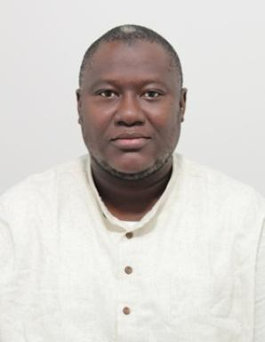 Abdulalim IBRAHIM

Identifiants chercheurs

- IdHAL : abdulalim-ibrahim
- ORCID : 0000-0002-1241-2067

Publications

Article dans une revue (4)

Vapor–Liquid Equilibrium of the Hydrogen Sulfide (H2S) – Benzene (C6H6) Binary System: Experimental and Modeling Study
Alain Valtz,Abdulalim Ibrahim,Christophe Coquelet,Antonin Chapoy
Fluid Phase Equilibria, 2026, 607, pp.114722. ⟨10.1016/j.fluid.2026.114722⟩
Article dans une revue
hal-05555448v1
Enhancing the Diffusion Channels of Silica‐Alginate Capsules for Microbial Encapsulation
Bilyamin Abdulmumin,Ismaila Mudi,Abdulalim Ibrahim,Abdulwasiu Abdurrahman,Helen Onyeaka
Engineering in Life Sciences, 2025, 25 (9), pp.e70002. ⟨10.1002/elsc.70002⟩
Article dans une revue
hal-05303268v1
Thermophysical Properties: Viscosity, Density, and Excess properties of 2-propanol and n-Decane mixtures from 283.15 K to 343.15 K under atmospheric conditions
Abdulalim Ibrahim,Christophe Coquelet,Alain Valtz,Fabienne Espitalier
Fluid Phase Equilibria, 2025, 589, pp.114254. ⟨10.1016/j.fluid.2024.114254⟩
Article dans une revue
hal-04736238v1
Ternary Choline Chloride-Based Deep Eutectic Solvents: A Review
Abdulalim Ibrahim,Marc Mulamba Tshibangu,Christophe Coquelet,Fabienne Espitalier
ChemEngineering, 2025, 9 (4), pp.84. ⟨10.3390/chemengineering9040084⟩
Article dans une revue (article de synthèse)
hal-05202807v1

Communication dans un congrès (1)

Liquid-Liquid Equilibria for Aromatic Extraction from Fuel Oil Using Deep Eutectic Solvents: Evaluating Hansen Solubility Parameters for Phase Equilibrium Prediction
Abdulalim Ibrahim,Christophe Coquelet,Fabienne Espitalier
ISYDES2025 - 1st International Symposium on Deep Eutectic Solvent, Università Degli Studi di Bari Aldo Moro; Regione Puglia; Città Di Bari; AReSS; Società Chimica Italiana; Chemistry Europe; Ordine Interprovinciale Dei Farmacisti Di Bari, Jun 2025, Bari (IT), Italy
Communication dans un congrès
hal-05166337v1

Poster de conférence (1)

Simulation of the solvent extraction process of aromatics from fuel oil using deep eutectic solvents.
Abdulalim Ibrahim,Christophe Coquelet,Fabienne Espitalier
SFGP 2024 - Société française de génie des procédés, Oct 2024, Deauville, France.
Poster de conférence
hal-04806536v1

Chapitre d'ouvrage (1)

State of Agro-wastes Management in Nigeria
Toyese Oyegoke,Ayandunmola Folake Oyegoke,Opeoluwa Olusola Fasanya,Abdul-Alim Gambo Ibrahim
Waste Recovery and Management, 1, CRC Press, pp.241-272, 2023, ⟨10.1201/9781003359784-14⟩
Chapitre d'ouvrage
hal-04759372v1

