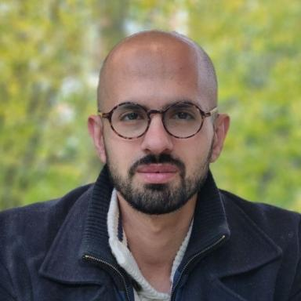 Abdulghani Ismail Chair Junior Professor at University Paris Saclay

Identifiants chercheurs

- IdHAL : abdulghani-ismail
- ORCID : 0000-0003-0970-7224

Présentation

Abdulghani Ismail, a doctor of pharmacy, is a Chair Junior Professor at University Paris Saclay. His work focus on micro/nanosystems including developing diagnostic technologies and biotherapies. He completed three postodocs in France (CEA Grenoble) and United kingdom (University of Oxford and University of Manchester). He possesses specialized expertise in analytical chemistry, biophysics, electrochemical measurements, nanomaterials, surface functionalization, and nanotechnology. Prof. Ismail received his Ph.D. from Sorbonne University in Paris, France. Throughout his doctoral studies, he extensively worked with nonomedicine diagnosis using electrochemical, bioanalytical and spectroscopic techniques. With experience as a research associate at the University of Oxford and CEA (Grenoble-France), he has made substantial contributions to innovative projects spanning diverse fields, focusing on the detection and characterization of biomolecules. His expertise includes techniques such as bipolar electrochemistry, surface plasmon resonance (SPR), micro/nano/angstrom-fluidics, electropolymerization, and electrochemical impedance detection. Dr. Ismail has been awarded several grants and awards for his exceptional work. Moreover, he is genuinely committed to training and mentoring Ph.D. and master's students and teaching multidisciplinary physics and chemistry courses at different universities

Publications

Article dans une revue (3)

Programmable memristors with two-dimensional nanofluidic channels
Abdulghani Ismail,Gwang-Hyeon Nam,Aziz Lokhandwala,Siddhi Vinayak Pandey,Kalluvadi Veetil Sauravet al.
Nature Communications, 2025, 16, ⟨10.1038/s41467-025-61649-6⟩
Article dans une revue
hal-05459900v1
Direct electrodeposition of adherent ultra-thin polypyrrole films on minimally pretreated silicon for localized biofunctionalization
Abdulghani Ismail,Adnane Bouzina,Stéphane Tawil,Marine Duplantier,Yoann Roupiozet al.
Synthetic Metals, 2025, 313, pp.117913. ⟨10.1016/j.synthmet.2025.117913⟩
Article dans une revue
hal-05206328v1
Long-term memory and synapse-like dynamics in two-dimensional nanofluidic channels
P. Robin,Théo Emmerich,A. Ismail,Antoine Niguès,Y. Youet al.
Science, 2023, 379 (6628), pp.161-167. ⟨10.1126/science.adc9931⟩
Article dans une revue
hal-03991876v1

Communication dans un congrès (1)

Electrochemiluminescence in planar micropore for application in single cell cytokine biosensing
Stéphane Tawil,Martial Billon,Neso Sojic,Loïc Leroy,Aurélie Bouchet-Spinelliet al.
XXVIII International Symposium on Bioelectrochemistry and Bioenergetics of the Bioelectrochemical Society, Bioelectrochemical Society, May 2024, Alcala de Henares (Madrid), Spain. ⟨10.1149/MA2024-01422370mtgabs⟩
Communication dans un congrès
hal-04929115v1

