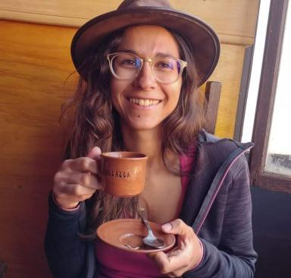 Adélaïde Genay Lecturer

Identifiants chercheurs

- IdHAL : adelaide-genay
- ORCID : 0000-0003-3151-1164

Présentation

I am a Lecturer in Computer Graphics and Visualisation at the University of Melbourne. My research interests include Mixed Reality, avatars, and data visualisation.

Publications

Article dans une revue (1)

Being an Avatar &quot;for Real&quot;: a Survey on Virtual Embodiment in Augmented Reality
Adélaïde Genay,Anatole Lécuyer,Martin Hachet
IEEE Transactions on Visualization and Computer Graphics, 2022, 28 (12), pp.5071-5090. ⟨10.1109/tvcg.2021.3099290⟩
Article dans une revue
hal-03320680v1

Communication dans un congrès (6)

From Diagrams to Experience: Data Visceralisation of Ecosystem State-and-Transition Models in Virtual Reality
Adélaïde Genay,Michael Neylan,Rick Laird,Thomas Romanis,Katrina Szeteyet al.
Designing Interactive Systems (DIS '25), Jul 2025, Funchal, Portugal. ⟨10.1145/3715336.3735774⟩
Communication dans un congrès
hal-05104458v1
Scaling Distributed Collaboration in Mixed Reality
Adélaïde Genay,Brandon Syiem,Emily Wong,Tiare Feuchtner,Jarrod Knibbeet al.
Extended Abstracts of the CHI Conference on Human Factors in Computing Systems, Apr 2025, Yokohama, Japan. ⟨10.1145/3706599.3706722⟩
Communication dans un congrès
hal-04896483v1
Preparing Users to Embody their Avatars in VR: Insights on the Effects of Priming, Mental Imagery, and Acting on Embodiment Experiences
Adélaïde Genay,Erika Kimura,Martin Hachet,Anatole Lécuyer,Yutaro Hiraoet al.
OzCHI 2024 - 36th Australian Conference on Human-Computer Interaction, Nov 2024, Brisbane, Australia
Communication dans un congrès
hal-04822108v1
I'm Transforming! Effects of Visual Transitions to Change of Avatar on the Sense of Embodiment in AR
Riku Otono,Adélaïde Genay,Monica Perusquía-Hernández,Naoya Isoyama,Hideaki Uchiyamaet al.
VR 2023 - IEEE Conference on Virtual Reality and 3D User Interfaces, IEEE, Mar 2023, Shanghai, China. pp.83-93
Communication dans un congrès
hal-03968274v1
What Can I Do There? Controlling AR Self-Avatars to Better Perceive Affordances of the Real World
Adélaïde Genay,Anatole Lécuyer,Martin Hachet
ISMAR 2022 - 21st IEEE International Symposium on Mixed and Augmented Reality, Oct 2022, Singapore, Singapore. pp.450-459, ⟨10.1109/ISMAR55827.2022.00061⟩
Communication dans un congrès
hal-03820756v1
Incarner un Avatar en Réalité Augmentée : Revue de la Littérature
Adélaïde Genay,Anatole Lécuyer,Martin Hachet
WACAI 2020 - Workshop sur les Affects, Compagnons artificiels et Interactions, CNRS, Université Toulouse Jean Jaurès, Université de Bordeaux, Jun 2020, Saint Pierre d'Oléron, France
Communication dans un congrès
hal-02933477v1

Poster de conférence (1)

Studying “Avatar Transitions” in Augmented Reality: Influence on Sense of Embodiment and Physiological Activity
Riku Otono,Adélaïde Genay,Monica Perusquía-Hernández,Naoya Isoyama,Hideaki Uchiyamaet al.
ISMAR-Adjunct 2022 - IEEE International Symposium on Mixed and Augmented Reality Adjunct, Oct 2022, Singapore, Singapore. IEEE, 12, pp.503-504, 2022, ⟨10.1109/ISMAR-Adjunct57072.2022.00106⟩
Poster de conférence
hal-03956728v1

Thèse (1)

Being a Virtual Avatar in a Real Environment : Design and Study of Avatar Embodiment in Augmented Reality
Adélaïde Genay
Human-Computer Interaction [cs.HC]. Université de Bordeaux, 2022. English. ⟨NNT : 2022BORD0376⟩
Thèse
tel-04004116v1

