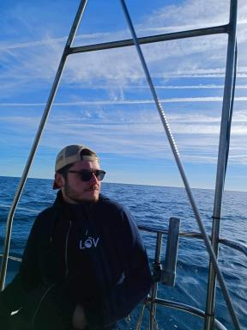 Alexandre Accardo PhD candidate at Laboratoire d'Océanographie de Villefranche (LOV)

Publications

Article dans une revue (5)

Meso‐ to Submesoscale Variability of Particulate Carbon Export Captured by a Glider‐Camera System in the Northeast Atlantic During the APERO Campaign
Elisabeth Chevillon,Anthony Bosse,Bruno Zakardjian,Alexandre Accardo,Lionel Guidiet al.
Journal of Geophysical Research. Oceans, 2026, 131 (5), pp.e2025JC023403. ⟨10.1029/2025jc023403⟩
Article dans une revue
hal-05630953v1
Combining the Underwater Vision Profiler 6 with sediment traps to measure in situ velocity of marine particles
Manon Laget,Alexandre Accardo,Marc Picheral,Camille Catalano,Lionel Guidiet al.
Limnology and Oceanography: Methods, 2026, pp.e70052. ⟨10.1002/lom3.70052⟩
Article dans une revue
hal-05578508v1
Intense and localized export of selected marine snow types at eddy edges in the South Atlantic Ocean
Alexandre Accardo,Rémi Laxenaire,Alberto Baudena,Sabrina Speich,Rainer Kikoet al.
Biogeosciences, 2025, 22 (5), pp.1183-1201. ⟨10.5194/bg-22-1183-2025⟩
Article dans une revue
hal-04984482v1
Marine snow morphology drives sinking and attenuation in the ocean interior
Yawouvi Dodji Soviadan,Miriam Beck,Joelle Habib,Alberto Baudena,Laetitia Dragoet al.
Biogeosciences, 2025, 22 (14), pp.3485-3501. ⟨10.5194/bg-22-3485-2025⟩
Article dans une revue
hal-05171892v1
Marine snow surface production and bathypelagic export at the Equatorial Atlantic from an imaging float
Joelle Habib,Lars Stemmann,Alexandre Accardo,Alberto Baudena,Franz Philip Tuchenet al.
Biogeosciences, In press, 22 (24), pp.7985-8003. ⟨10.5194/bg-22-7985-2025⟩
Article dans une revue
hal-05553425v1

Communication dans un congrès (1)

Resolving the scales of plankton ecology and biogeochemical fluxes with the Underwater Vision Profiler
Marc Picheral,Camille Catalano,Alexandre Accardo,Alberto Baudena,Hervé Claustreet al.
ASLO Aquatic Sciences Meeting, 2023, Palma de Mallorca, Spain
Communication dans un congrès
hal-04194467v1

