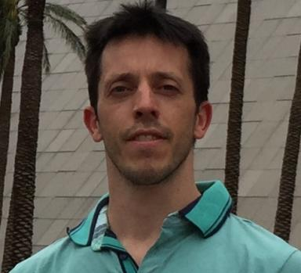 Alexandre da Silva Veith

Identifiants chercheurs

- IdHAL : alexandre-da-silva-veith
- ORCID : 0000-0001-5130-1792
- cv.identifier.google scholar : https://scholar.google.com/citations?user=ZrkbeCQAAAAJ&hl=en
- ResearcherID : N-2826-2017

Présentation

Publications

Communication dans un congrès (8)

Monte-Carlo Tree Search and Reinforcement Learning for Reconfiguring Data Stream Processing on Edge Computing
Alexandre da Silva Veith,Marcos Dias de Assuncao,Laurent Lefevre
SBAC-PAD 2019 - International Symposium on Computer Architecture and High Performance Computing, Oct 2019, Campo Grande, Brazil. pp.1-8
Communication dans un congrès
hal-02305472v1
Multi-Objective Reinforcement Learning for Reconfiguring Data Stream Analytics on Edge Computing
Alexandre da Silva Veith,Felipe Rodrigo de Souza,Marcos Dias de Assuncao,Laurent Lefèvre,Julio C. S. dos Anjos
ICPP 2019 - 48th International Conference on Parallel Processing, Aug 2019, Kyoto, Japan. pp.1-10, ⟨10.1145/3337821.3337894⟩
Communication dans un congrès
hal-02140844v1
Distributed Operator Placement for IoT Data Analytics Across Edge and Cloud Resources
Eduard Gibert Renart,Alexandre da Silva Veith,Daniel Balouek-Thomert,Marcos Dias de Assuncao,Laurent Lefèvreet al.
CCGrid 2019 - 19th Annual IEEE/ACM International Symposium in Cluster, Cloud, and Grid Computing, May 2019, Larnaca, Cyprus. pp.1-10, ⟨10.1109/CCGRID.2019.00060⟩
Communication dans un congrès
hal-02103942v1
Latency-Aware Placement of Data Stream Analytics on Edge Computing
Alexandre da Silva Veith,Marcos Dias de Assuncao,Laurent Lefèvre
Service-Oriented Computing, Nov 2018, Hangzhou, Zhejiang, China. pp.215-229
Communication dans un congrès
hal-01875936v1
Aten: A Dispatcher for Big Data Applications in Heterogeneous Systems
Paulo de Souza Junior,Kassiano J Matteussi,Julio C S dos Anjos,Jobe D D Dos Santos,Alexandre da Silva Veithet al.
2018 International Conference on High Performance Computing Simulation (HPCS), Jul 2018, Orléans, France. pp.585-592, ⟨10.1109/HPCS.2018.00098⟩
Communication dans un congrès
hal-01876973v1
Enabling Strategies for Big Data Analytics in Hybrid Infrastructures
Julio Anjos,Kassiano J Matteussi,Paulo R R de Souza,Claudio Geyer,Alexandre da Silva Veithet al.
2018 International Conference on High Performance Computing Simulation (HPCS), Jul 2018, Orléans, France. pp.869-876
Communication dans un congrès
hal-01875952v1
Assessing the Impact of Network Bandwidth and Operator Placement on Data Stream Processing for Edge Computing Environments
Alexandre da Silva Veith,Marcos Dias de Assuncao,Laurent Lefèvre
COMPAS'2017 - Conférence d’informatique en Parallélisme, Architecture et Système, Jun 2017, Antibes, France
Communication dans un congrès
hal-01574448v1
Strategies for Big Data Analytics through Lambda Architectures in Volatile Environments
Alexandre da Silva Veith,Julio C. S. dos Anjos,Edison Pignaton de Freitas,Thomas Lampoltshammer,Claudio Geyer
IFAC, Nov 2016, Porto Alegre, Brazil. pp.114-119
Communication dans un congrès
hal-01574656v1

Poster de conférence (1)

Latency-Aware Strategies for Placing Data Stream Analytics onto Edge Computing
Alexandre da Silva Veith,Marcos Dias de Assuncao,Laurent Lefèvre
HotEdge'18 - USENIX Workshop on Hot Topics in Edge Computing, Jul 2018, Boston, United States. pp.1, 2018
Poster de conférence
hal-01875999v1

