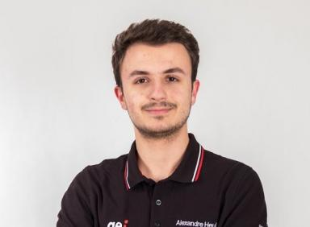 Alexandre Heuillet AI Scientist

Identifiants chercheurs

- IdHAL : alexandre-heuillet
- ORCID : 0000-0003-2109-7895
- IdRef : 275528014
- arXiv : heuillet_a_1

Publications

Article dans une revue (6)

Efficient Automation of Neural Network Design: A Survey on Differentiable Neural Architecture Search
Alexandre Heuillet,Ahmad Nasser,Hichem Arioui,Hedi Tabia
ACM Computing Surveys, 2024, 56 (11), pp.270. ⟨10.1145/3665138⟩
Article dans une revue
hal-04104238v1
DARIO: Differentiable vision transformer pruning with low-cost proxies
Haozhe Sun,Alexandre Heuillet,Felix Mohr,Hedi Tabia
IEEE Journal of Selected Topics in Signal Processing, 2024, 18 (6), pp.997--1009. ⟨10.1109/JSTSP.2024.3501685⟩
Article dans une revue
hal-04813053v1
D-DARTS: Distributed Differentiable Architecture Search
Alexandre Heuillet,Hedi Tabia,Hichem Arioui,Kamal Youcef-Toumi
Pattern Recognition Letters, 2023, 176, pp.42--48. ⟨10.1016/j.patrec.2023.10.019⟩
Article dans une revue
hal-04270973v1
NASiam: Efficient Representation Learning using Neural Architecture Search for Siamese Networks
Alexandre Heuillet,Hedi Tabia,Hichem Arioui
Procedia Computer Science, 2023, 222, pp.58--70. ⟨10.1016/j.procs.2023.08.144⟩
Article dans une revue
hal-04200729v1
Collective eXplainable AI: Explaining Cooperative Strategies and Agent Contribution in Multiagent Reinforcement Learning with Shapley Values
Alexandre Heuillet,Fabien Couthouis,Natalia Diaz-Rodriguez
IEEE Computational Intelligence Magazine, 2022, 17 (1), pp.59-71. ⟨10.1109/MCI.2021.3129959⟩
Article dans une revue
hal-03549473v1
Explainability in Deep Reinforcement Learning
Alexandre Heuillet,Fabien Couthouis,Natalia Díaz-Rodríguez
Knowledge-Based Systems, 2021, ⟨10.1016/j.knosys.2020.106685⟩
Article dans une revue
hal-03059366v1

Thèse (1)

Exploring deep neural network differentiable architecture design
Alexandre Heuillet
Artificial Intelligence [cs.AI]. Université Paris-Saclay, 2023. English. ⟨NNT : 2023UPASG069⟩
Thèse
tel-04420933v1

Communication dans un congrès (1)

Automated Siamese Network Design for Image Similarity Computation
Alexandre Heuillet,Hedi Tabia,Hichem Arioui
20th International Conference on Content-based Multimedia Indexing (CBMI 2023), Sep 2023, Orleans, France. pp.8--13, ⟨10.1145/3617233.3617243⟩
Communication dans un congrès
hal-04420941v1

Pré-publication, Document de travail (1)

D-DARTS: Distributed Differentiable Architecture Search
Alexandre Heuillet,Hedi Tabia,Hichem Arioui,Kamal Youcef-Toumi
2021
Pré-publication, Document de travail
hal-03324857v1

