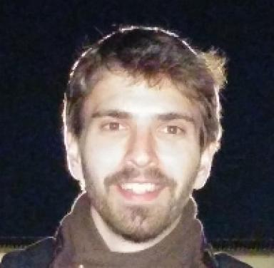 Alexis I. Aravanis Associate Professor (Tenured) at the Laboratory of Signals and Systems (L2S) of Université Paris-Saclay / CNRS / CentraleSupélec, Paris, France.Joint co-affiliation: Université Paris-Saclay, CNRS, CentraleSupélec

Identifiants chercheurs

- IdHAL : alexis-aravanis
- ORCID : 0000-0002-4429-1941

Présentation

Publications

Article dans une revue (5)

Broadcasting in Cognitive Radio Networks: A Fountain Codes Approach
Lam-Thanh Tu,Tan Nguyen,Tran Trung Duy,Phuong Tran,Miroslav Voznaket al.
IEEE Transactions on Vehicular Technology, 2022, 71 (10), pp.11289-11294. ⟨10.1109/TVT.2022.3188969⟩
Article dans une revue
hal-04113437v1
On the Spectral Efficiency of LoRa Networks: Performance Analysis, Trends and Optimal Points of Operation
Lam-Thanh Tu,Abbas Bradai,Yannis Pousset,Alexis I Aravanis
IEEE Transactions on Communications, 2022, ⟨10.1109/TCOMM.2022.3148784⟩
Article dans une revue
hal-02971898v2
Energy Efficiency Analysis of LoRa Networks
Lam-Thanh Tu,Abbas Bradai,Yannis Pousset,Alexis I. Aravanis
IEEE Wireless Communications Letters, 2021, ⟨10.1109/LWC.2021.3084996⟩
Article dans une revue
hal-02977258v2
A tractable closed form approximation of the ergodic rate in Poisson cellular networks
Alexis I Aravanis,Lam Thanh Tu,Olga Muñoz,Antonio Pascual-Iserte,Marco Di Renzo
EURASIP Journal on Wireless Communications and Networking, 2019, 2019, ⟨10.1186/s13638-019-1499-9⟩
Article dans une revue
hal-02395865v1
On the Coordination of Base Stations in Ultra Dense Cellular Networks
Alexis Aravanis,Olga Muñoz,Antonio Pascual-Iserte,Marco Di Renzo
IEEE Access, 2019
Article dans une revue
hal-02387603v1

Communication dans un congrès (2)

Energy-Efficient Placement and Association in Disaggregated O-RAN
Hiba Hojeij,Sahar Hoteit,Véronique Vèque,Alexis I Aravanis
IEEE CNSM 2025, Oct 2025, Bologna, Italy
Communication dans un congrès
hal-05329935v1
On the Coordination of Base Stations in Ultra Dense Cellular Networks
Alexis Aravanis,Olga Muñoz,Antonio Pascual-Iserte,Marco Di Renzo
2019 IEEE 89th Vehicular Technology Conference (VTC2019-Spring), Apr 2019, Kuala Lumpur, Malaysia. ⟨10.1109/VTCSpring.2019.8746531⟩
Communication dans un congrès
hal-02395754v1

Chapitre d'ouvrage (1)

Catching the 6G Wave by Using Metamaterials: A Reconfigurable Intelligent Surface Paradigm
Marco Di Renzo,Alexis I Aravanis
Emmanuel Bertin; Noel Crespi; Thomas Magedanz. Shaping Future 6G Networks, 2022 John Wiley & Sons Ltd., 2021, 9781119765516. ⟨10.1002/9781119765554.ch6⟩
Chapitre d'ouvrage
hal-04113860v1

