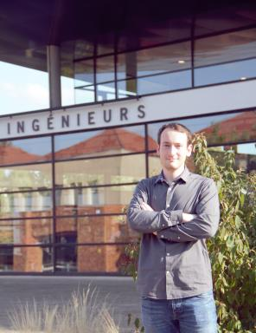 Amaury Saint-Jore

Identifiants chercheurs

- IdHAL : amaury-saint-jore
- ORCID : 0009-0009-5292-8234
- IdRef : 294085300
- cv.identifier.google scholar : https://scholar.google.fr/citations?user=V9sxtCYAAAAJ

Publications

Logiciel (1)

Heterogeneous Multi-Agent Systems
Amaury Saint-Jore
2025, ⟨swh:1:dir:ab2b76907e31ac42b384799df3c8c5c6742e61bd;origin=https://github.com/Amaury-SJ/heterogeneous-multi-agent-systems;visit=swh:1:snp:2feadf1d3e72f66a2fa7bc056cde7281f34bf60a;anchor=swh:1:rev:ec2948b9665d761611fa0b8f308cea38e86fcca3⟩
Logiciel
hal-05285843v1

Thèse (1)

Systèmes multi-agents hétérogènes appliqués à la robotique mobile collaborative interconnectée
Amaury Saint-Jore
Informatique [cs]. Université de Lorraine, 2025. Français. ⟨NNT : 2025LORR0186⟩
Thèse
tel-05538139v1

Article dans une revue (1)

Assessing intra- and inter-community trustworthiness in IoT: A role-based attack-resilient dynamic trust management model
Runbo Su,Arbia Riahi,Enrico Natalizio,Pascal Moyal,Amaury Saint-Joreet al.
Internet of Things, 2024, 26, pp.101213. ⟨10.1016/j.iot.2024.101213⟩
Article dans une revue
hal-04620889v1

Communication dans un congrès (2)

A Role-based Trust Model assessing IoA services: First Results on Real MAS Implementation by using ROS 2
Runbo Su,Amaury Saint-Jore
The International Conference on Embedded Wireless Systems and Networks (EWSN 2023), Sep 2023, Rende, Italy. ⟨10.5555/3639940.3639978⟩
Communication dans un congrès
hal-04161463v1
HMAS: enabling seamless collaboration between drones, quadruped robots, and human operators with efficient spatial awareness
Amaury Saint-Jore,Ye -Qiong Song,Laurent Ciarletta
IEEE 21th International Conference on Embedded and Ubiquitous Computing (EUC), Nov 2023, Exeter, United Kingdom. pp.2503-2510, ⟨10.1109/TrustCom60117.2023.00351⟩
Communication dans un congrès
hal-04311426v1

Chapitre d'ouvrage (1)

Amoebae for clustering: a bio-inspired cellular automata method for data classification
Amaury Saint-Jore,Nazim A. Fatès,Emmanuel Jeandel
Automata and Complexity, 42, Springer, Cham, pp.417-432, 2022, 978-3-030-92553-6. ⟨10.1007/978-3-030-92551-2_23⟩
Chapitre d'ouvrage
hal-02973830v1

