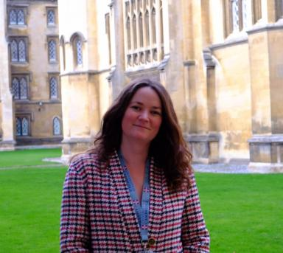 Amélie Moisy

Identifiants chercheurs

- IdHAL : amelie-moisy
- ORCID : 0009-0008-9911-1494

Publications

Article dans une revue (1)

Multiphysics simulation of an anisothermal reactive spontaneous capillary rise between electric rotor wires
Amélie Moisy,Sébastien Comas-Cardona,Nicolas Désilles,Pascal Genevée,Jere Kolehmainen
Frontiers in Materials, 2023, 10, pp.1124176. ⟨10.3389/fmats.2023.1124176⟩
Article dans une revue
hal-04585527v1

Communication dans un congrès (3)

Experimental assessment and 2D-Modelling of the viscous sintering of superimposed filaments based on biopolymer
Laurent Chaunier,Mélanie Thadasack,Anne-Laure Réguerre,Achraf Chebbi,Lucas Huttinet al.
ESAFORM 2025, ESAFORM, May 2025, Paestum, Italy. pp.2-11, ⟨10.21741/9781644903599-1⟩
Communication dans un congrès
hal-05063496v1
Experimental design of a millifluidic flow-focusing method for biomimetic nanocellulose and hemicellulose-based biopolymer fibres
Amélie Moisy,Hugo Voisin,Joëlle Davy,Bernard Cathala,Sofiane Guessasma
26ème Congrès Français de Mécanique, Aug 2025, Metz, France
Communication dans un congrès
hal-05414506v1
Characterization and modeling of the impregnation process of electric engines's rotors with a reactive thermosetting resin
Amélie Moisy,Sebastien Comas-Cardona,Nicolas Desilles,Pascal Genevée,Jere Kolehmainen
ECCM20 European Conference on Composite Materials, Jun 2022, Lausanne, Switzerland
Communication dans un congrès
hal-05525006v1

Poster de conférence (3)

Manufacturing Biomimetic Fibres: Creating databases for Multiphysics Process Optimization
Amélie Moisy,Hugo Voisin,Joëlle Davy,Bernard Cathala,Sofiane Guessasma
Assemblée générale du PEPR DIADEM 2025, Nov 2025, Saclay, France. Unpublished, 2025, ⟨10.13140/RG.2.2.34235.89129⟩
Poster de conférence
hal-05525122v1
On the design of biomimetic nanocellulose and hemicellulose-based biopolymers fibers by flow-focusing method
Amélie Moisy,Hugo Voisin,Joëlle Davy,Bernard Cathala,Sofiane Guessasma
Assemblée générale du PEPR DIADEM 2024, Nov 2024, Lyon, France. Unpublished, 2024, ⟨10.13140/RG.2.2.10802.62403⟩
Poster de conférence
hal-05525103v1
Predict automotive electric rotor coil multiphysics' impregnation
Amélie Moisy,S Comas Cardona,P Genevée
COMSOL Multiphysics Conference, Oct 2023, Munich, Germany. , Proceedings of COMSOL Multiphysics Conference 2023, ⟨10.13140/RG.2.2.20611.07207⟩
Poster de conférence
hal-05517554v1

