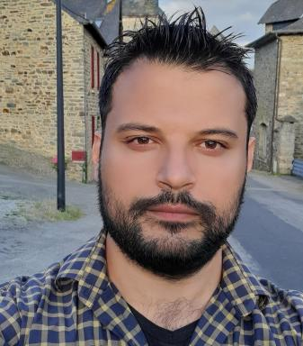 Ammar Hdaifeh

Identifiants chercheurs

- IdHAL :
ammar-hdaifeh2
- ORCID :
0000-0001-8629-1563

Présentation

Ammar has an international master degree in analyzing and managing Health and Food Risk in France. He is passionate about turning research results into products in order to reduce global food waste and keep this planet safe. He has acquired during his professional career deep knowledge and expertise in Environment and Agri-Food sector

Publications

Article dans une revue (5)

How do human behaviour and infrastructure interact in achieving biowaste policy objectives?
Ammar Hdaifeh,Sylvie Huet,Jean-Denis Mathias
Journal of Cleaner Production, 2025, 510, pp.145571. ⟨10.1016/j.jclepro.2025.145571⟩
Article dans une revue
hal-05064547v1
The Russia-Ukraine Conflict: Its Implications for the Global Food Supply Chains
Sandeep Jagtap,Hana Trollman,Frank Trollman,Guillermo Garcia-Garcia,Carlos Parra-Lópezet al.
Foods, 2022, 11 (14), pp.2098. ⟨10.3390/foods11142098⟩
Article dans une revue
hal-03735981v1
The Russia-Ukraine Conflict: Its Implications for the Global Food Supply Chains
Sandeep Jagtap,Hana Trollman,Frank Trollman,Guillermo Garcia-Garcia,Carlos Parra-Lópezet al.
Foods, 2022, 11 (14), pp.2098. ⟨10.3390/foods11142098⟩
Article dans une revue
hal-03731351v1
Critical Analysis of Pork QMRA Focusing on Slaughterhouses: Lessons from the Past and Future Trends
Ammar Hdaifeh,Tahreem Khalid,Géraldine Boué,Enda Cummins,Sandrine Guillouet al.
Foods, 2020, 9 (11), pp.1-21. ⟨10.3390/foods9111704⟩
Article dans une revue (article de synthèse)
hal-03222106v1
Review of Quantitative Microbial Risk Assessment in Poultry Meat: The Central Position of Consumer Behavior
Tahreem Khalid,Ammar Hdaifeh,Michel M. Federighi,Enda Cummins,Géraldine Bouéet al.
Foods, 2020, 9 (11), pp.1-26. ⟨10.3390/foods9111661⟩
Article dans une revue
hal-03224966v1

Logiciel (1)

Biowaste management model
Sylvie Huet,Ammar Hdaifeh
2024, ⟨swh:1:dir:fd812855cfa82bfeae00d70121ad79dde10e8477;origin=https://forgemia.inra.fr/lisc/Beecome2;visit=swh:1:snp:5becc98d9b0ed04bfcf29587ee3565f976aa1044;anchor=swh:1:rev:7673a7247efd1b7bed7283ede323a28e33a657d7⟩
Logiciel
hal-05015770v1

