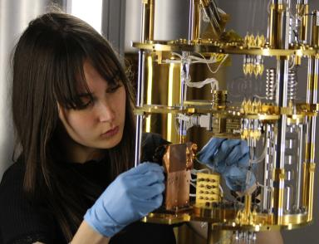 Anaïs Besnard Ph.D. Student at Institut d'Astrophysique Spatiale (IAS), Paris-Saclay University, Orsay, France

Publications

Poster de conférence (4)

DRACuLA : Detector irRAdiation Cryogenic faciLity for Astrophysics
Anaïs Besnard,Valentin Sauvage
Bi-national conference on Detectors R&D, Nov 2025, Paris, France.
Poster de conférence
hal-05372754v1
An overview of the latest developments on the Closed-Cycle Dilution Refrigerator for space applications
Anaïs Besnard,Valentin Sauvage,Bruno Maffei
18th Cryogenics 2025 IIR conference, Apr 2025, Prague, Czech Republic.
Poster de conférence
hal-05372745v1
A cryogenic facility to characterize detector-particle interactions
Anaïs Besnard,Valentin Sauvage,Samantha Stever,Bruno Maffei
SPIE Astronomical Telescopes + Instrumentation, Jun 2024, Yokohama, Japan.
Poster de conférence
hal-05372737v1
Cryogenic developments for future CMB projects
Anaïs Besnard
Journée annuelle de l'Axe Astrophysique de la Graduate School de Physique de l'Université Paris-Saclay, Oct 2023, Orsay, France.
Poster de conférence
hal-05372728v1

