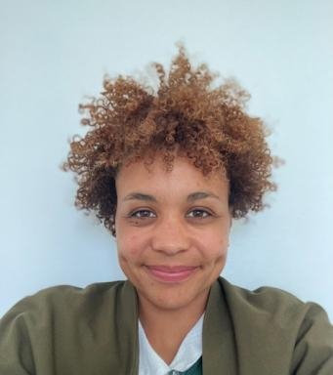 Anaïs Ferguson Doctorante en Sciences de l'Education et de la Formation

Identifiants chercheurs

- IdHAL : anais-ferguson
- ORCID : 0009-0002-5239-434X

Publications

Communication dans un congrès (1)

Dancing with Pairs is Difficult: You Have to Be Together
Sigolène Couchot-Schiex,Anaïs Ferguson
European Conference on Educational Research (ECER 2025), European Educational Research Association (EERA), Sep 2025, Belgrade, Serbia
Communication dans un congrès
hal-05333727v1

