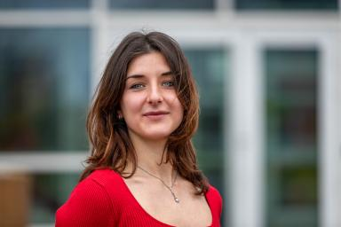 Anna Déniel Luque Doctorante (2a)

Identifiants chercheurs

- IdHAL : anna-deniel-luque
- ORCID : 0009-0003-2333-6519

Publications

Article dans une revue (2)

Production of enriched protein extracts from cultivated Ulva sp. (Chlorophyta, Ulvales) by high-pressure homogenization
Anna Déniel Luque,Hugo Pliego-Cortés,Anne-Sophie Burlot,Nolwenn Terme,Marie Furicet al.
Frontiers in Marine Science, 2025, 12, ⟨10.3389/fmars.2025.1675710⟩
Article dans une revue
hal-05321997v1
Production of enriched protein extracts from cultivated Ulva sp. (Chlorophyta, Ulvales) by high-pressure homogenization
Anna Déniel Luque,Hugo Pliego-Cortés,Anne-Sophie Burlot,Nolwenn Terme,Marie Furicet al.
Frontiers in Marine Science, 2025, 12, ⟨10.3389/fmars.2025.1675710⟩
Article dans une revue
hal-05382056v1

Communication dans un congrès (4)

Effects of nutrient enrichment on protein and amino acid content in the seaweed Ulva sp. cultivated in a land-based system
Hugo Pliego-Cortés,Emeline Creis Bendelac,Alexandre Berthelot,Anne-Sophie Burlot,Anna Déniel Luqueet al.
X Mexican Congress of Phycology, Société phycologique Mexicaine, Nov 2025, Mérida, Mexico
Communication dans un congrès
hal-05512951v1
Production of enriched protein extracts after High-Pressure Homogenization from cultivated Ulva spp. (Chlorophyta, Ulvales)
Anna Déniel Luque,Hugo Pliego-Cortés,Anne-Sophie Burlot,Nolwenn Terme,Marie Furicet al.
13th International Marine Biotechnology Conference, Université Bretagne Occidentale; Université Bretagne Sud; Laboratoire de Biotechnologie et Chimie Marines; LEMAR L. Environnement marin, Jul 2025, Brest, France
Communication dans un congrès
hal-05513032v1
Ulva sp. from Brittany, a curse or a golden resource? New protein-enriched ingredients from Ulva sp. for the hospital catering sector.
Anne-Sophie Burlot,Anna Déniel Luque,Nolween Terme,Gilles Bedoux,Hugo Pliego-Cortéset al.
Cost Action CA20106 – Seawheat final conference., Cost action Seawheat, Sep 2025, Bremerhaven, Germany
Communication dans un congrès
hal-05513068v1
Ulva sp. from Brittany, a curse or a golden resource?
Anne-Sophie Burlot,Anna Déniel Luque,Gilles Bedoux,Thomas Latire,Hugo Pliego-Cortéset al.
13th International Marine Biotechnology Conference, Université Bretagne Occidentale; Université Bretagne Sud, Jul 2025, Brest, France
Communication dans un congrès
hal-05513050v1

