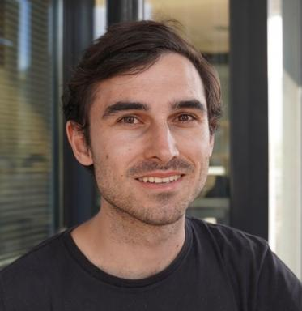 Antoine BARRIER Post-doctorant au Grenoble Institut des Neurosciences

Identifiants chercheurs

- IdHAL : antoine-barrier
- ORCID : 0000-0001-5224-0581
- cv.identifier.google scholar : https://scholar.google.fr/citations?user=2Y4lyzYAAAAJ

Publications

Article dans une revue (2)

MR-WAVES: MR Water-diffusion And Vascular Effects Simulations
Thomas Coudert,Maitê Silva Martins Marçal,Aurélien Delphin,Antoine Barrier,Lila Cungeet al.
Magnetic Resonance in Medicine, 2025, 94 (5), pp.2234-2248. ⟨10.1002/mrm.30629⟩
Article dans une revue
hal-05187172v1
MARVEL: MR Fingerprinting with Additional micRoVascular Estimates using bidirectional LSTMs
Antoine Barrier,Thomas Coudert,Aurélien Delphin,Benjamin Lemasson,Thomas Christen
Medical image computing and computer-assisted intervention : MICCAI .. International Conference on Medical Image Computing and Computer-Assisted Intervention, 2024, Lecture Notes in Computer Science, 15002, pp.259-269. ⟨10.1007/978-3-031-72069-7_25⟩
Article dans une revue
hal-04647024v1

Communication dans un congrès (5)

Nouveaux développements sur l’IRM Fingerprint Vasculaire
Maitê Marçal,Thomas Coudert,Aurelien Delphin,Antoine Barrier,Emmanuel L Barbieret al.
Société Française de Résonance Magnétique en Biologie et Médecine, Mar 2025, Saint Malo, France, France
Communication dans un congrès
hal-05078193v1
Advanced MR vascular Fingerprinting
Maitê Marçal,Thomas Coudert,Aurelien Delphin,Antoine Barrier,Emmanuel L Barbieret al.
International Society for Magnetic Resonance in Medicine, May 2025, Honolulu (Hawaii), USA, United States
Communication dans un congrès
hal-05078184v1
Contrast-free Blood Volume, Microvascular Properties and Relaxometry mapping using bSSFP MR Fingerprinting
Thomas Coudert,Aurelien Delphin,Loïc Legris,Antoine Barrier,Jan Warnkinget al.
2024 ISMRM & ISMRT Annual Meeting & Exhibition, ISMRM; ISMRT, May 2024, Singapore, Singapore
Communication dans un congrès
hal-04647825v1
On Best-Arm Identification with a Fixed Budget in Non-Parametric Multi-Armed Bandits
Antoine Barrier,Aurélien Garivier,Gilles Stoltz
ALT 2023 - The 34th International Conference on Algorithmic Learning Theory, Feb 2023, Singapour, Singapore
Communication dans un congrès
hal-03792668v2
A Non-asymptotic Approach to Best-Arm Identification for Gaussian Bandits
Antoine Barrier,Aurélien Garivier,Tomáš Kocák
AISTATS 2022 - 25th International Conference on Artificial Intelligence and Statistics, Mar 2022, Virtual, Spain
Communication dans un congrès
hal-03236583v2

Pré-publication, Document de travail (1)

Dynamic learning rate for deep reinforcement learning: a bandit approach
Henrique Donâncio,Antoine Barrier,Leah South,Florence Forbes
2024
Pré-publication, Document de travail
hal-04915351v1

Thèse (1)

Contributions to a Theory of Pure Exploration in Sequential Statistics
Antoine Barrier
Machine Learning [cs.LG]. Ecole normale supérieure de lyon - ENS LYON, 2023. English. ⟨NNT : 2023ENSL0024⟩
Thèse
tel-04192097v1

