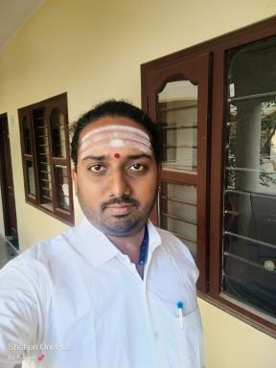 R Aravindhan Associate Researcher, Dept. of Indology, IFP, Pondicherry

Identifiants chercheurs

- IdHAL : aravindhan-r

Publications

Article dans une revue (1)

Śaivāgame Buddhitattvam
R. Aravindhan
Viśvabhāratī, Journal of Department of Sanskrit, 2025, 7, pp.323-330
Article dans une revue
hal-05433445v1

Communication dans un congrès (6)

Challenges and Methodologies for the Critical Edition of Śrīmatsahasrāgama
R. Aravindhan
International Conference on Editing Śaiva Texts and Commentaries: Issues of Methodology and Interpretation, Department of Indology, The French Institute of Pondicherry, Dec 2024, Pondicherry, India
Communication dans un congrès
hal-04903416v1
Śaivāgamē Patilakṣaṇam
R. Aravindhan
National Conference on Saivagama with special reference to the Metaphysical aspects, Karnataka Samskrit University & Sri Veda Agama Research Institute, Bengaluru., Mar 2024, Bengaluru, India
Communication dans un congrès
hal-04905099v1
Samskaras as described in Srimat Agora Sivacharyar’s Saivashodashaprakashika
R. Aravindhan
International Seminar on Human Development & Samskar, Vedic Vidya Kendra, Puducherry & Department of Sanskrit, Pondicherry University, Sep 2024, Pondicherry, India
Communication dans un congrès
hal-04903401v1
Aṣṭabandhanavidhiḥ in Śrīmatsahasrāgama
R. Aravindhan
National Seminar on Saivagama, Sri Venkateswara Vedic University, Tirupati & Sri Iyamani Sivachariyar Memorial Religious and Charitable Trust, Nattarasankottai., Jan 2024, Nattarasankottai, India
Communication dans un congrès
hal-04905098v1
The Yoga in the light of Śaivāgama
R. Aravindhan
All India Oriental Conference, Fifty one, Central Sanskrit University, Bharatiya Vidvat Parishat and Sri Puttige Matha, Udupi, Oct 2024, Udupi, India
Communication dans un congrès
hal-04905103v1
Śrīmatsahasrāgamasya Vaiśiṣṭyam
R. Aravindhan
Saivagama Special Lecture Series, French Institute of Pondicherry, Śrī Śrī Gurukulam Āgama Vidyārthigal Sēvā Samitiḥ & Sri Sri Veda Agama Research Institute, Bengaluru, Jul 2024, Pondicherry, India
Communication dans un congrès
hal-04905100v1

