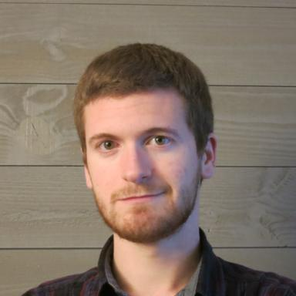 Arnaud Quillent

Identifiants chercheurs

- IdHAL : arnaud-quillent
- ORCID : 0000-0001-6358-1293
- IdRef : 285172611
- cv.identifier.google scholar : https://scholar.google.fr/citations?user=Fft8auYAAAAJ

Publications

Article dans une revue (4)

Using Machine Learning on MRI Radiomics to Diagnose Parotid Tumours Before Comparing Performance with Radiologists: A Pilot Study
Samy Ammari,Arnaud Quillent,Víctor Elvira,François Bidault,Gabriel Garciaet al.
Journal of Imaging Informatics in Medicine, 2025, 38 (3), pp.1496-1508. ⟨10.1007/s10278-024-01255-y⟩
Article dans une revue
hal-04734195v1
Radiomics-Based Method for Predicting the Glioma Subtype as Defined by Tumor Grade, IDH Mutation, and 1p/19q Codeletion
Yingping Li,Samy Ammari,Litti Lawrance,Arnaud Quillent,Tarek Assiet al.
Cancers, 2022, 14 (7), pp.1778. ⟨10.3390/cancers14071778⟩
Article dans une revue
hal-03647258v1
Machine-Learning-Based Radiomics MRI Model for Survival Prediction of Recurrent Glioblastomas Treated with Bevacizumab
Samy Ammari,Raoul Sallé de Chou,Tarek Assi,Mehdi Touat,Emilie Chouzenouxet al.
Diagnostics, 2021, 11 (7), pp.1263. ⟨10.3390/diagnostics11071263⟩
Article dans une revue
hal-03292019v1
A Predictive Clinical-Radiomics Nomogram for Survival Prediction of Glioblastoma Using MRI
Samy Ammari,Raoul Sallé de Chou,Corinne Balleyguier,Emilie Chouzenoux,Mehdi Touatet al.
Diagnostics, 2021, 11 (11), pp.2043. ⟨10.3390/diagnostics11112043⟩
Article dans une revue
hal-03424507v1

Thèse (1)

Role of deep learning into three-dimensional reconstruction for breast tomosynthesis
Arnaud Quillent
Medical Imaging. Institut Polytechnique de Paris, 2025. English. ⟨NNT : 2025IPPAT012⟩
Thèse
tel-05095928v1

Communication dans un congrès (3)

Deep-learning uncertainty estimation for data-consistent breast tomosynthesis reconstruction
Arnaud Quillent,Vincent Bismuth,Isabelle Bloch,Christophe Kervazo,Saïd Ladjal
21st International Symposium on Biomedical Imaging (ISBI 2024), IEEE Signal Processing Society; IEEE Engineering in Medicine and Biology Society, May 2024, Athens, Greece
Communication dans un congrès
hal-04598329v1
A deep learning method trained on synthetic data for digital breast tomosynthesis reconstruction
Arnaud Quillent,Vincent Bismuth,Isabelle Bloch,Christophe Kervazo,Saïd Ladjal
6th International Conference on Medical Imaging with Deep Learning (MIDL 2023), MIDL Foundation, Jul 2023, Nashville, TN, United States. pp.1813-1825
Communication dans un congrès
hal-04178641v2
Machine-learning based guided diagnosis of parotid tumours from MRI
Arnaud Quillent,Samy Ammari,Emilie Chouzenoux,Víctor Elvira,Nathalie Lassau
ISBI 2023 - IEEE International Symposium on Biomedical Imaging, Apr 2023, Cartagena (Colombia), Colombia
Communication dans un congrès
hal-04407914v1

