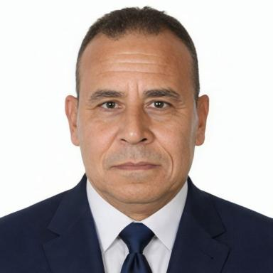 ASHRAF GOMAA ALY KHALAF MOHAMED President of the MAS Association, CEO of Edge Company Aly Khalaf Mohamed Ashraf Gomaa in Italy,CEO of Edge Company Egiziano Limit a.s.a. SRL in Romania,

Publications

Rapport (1)

Ecology_Principl
Ashraf Gomaa Aly Khalaf Mohamed
M.a.s. Association, Italy. 2025
Rapport
hal-05413575v1

Chapitre d'ouvrage (2)

The Human Journey of the Widow
Ashraf Gomaa Aly Khalaf Mohamed
The Human Journey of the Widow, figshare; ASHRAF KHALAF, 2025, The Human Journey of the Widow, ⟨10.6084/m9.figshare.30911942⟩
Chapitre d'ouvrage
hal-05423807v1
Women Between Rights and Responsibilities
Ashraf Gomaa Aly Khalaf Mohamed
Women Between Rights and Responsibilities, figshare, 2025, ⟨10.6084/m9.figshare.30880139⟩
Chapitre d'ouvrage
hal-05415501v1

