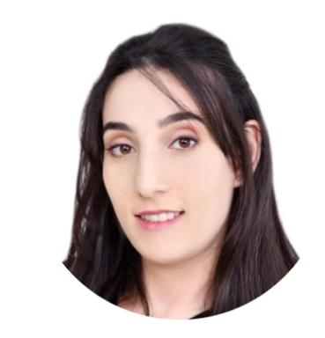 Asma KHARRAT Doctorante

Identifiants chercheurs

- IdHAL : asma-kharrat
- ORCID : 0000-0002-3964-2313

Publications

Communication dans un congrès (5)

Learning What Matters for Effective Historical Manuscripts Recognition
Asma Kharrat,Fadoua Drira,Franck Lebourgeois,Bertrand Kerautret
18th International Conference on Agents and Artificial Intelligence, Mar 2026, Marbella, Spain. pp.4247-4256, ⟨10.5220/0014342600004052⟩
Communication dans un congrès
hal-05584841v1
Toward Digits Recognition Using Continual Learning
Asma Kharrat,Fadoua Drira,Frank Le Bourgeois,Christophe Garcia
2023 IEEE 25th International Workshop on Multimedia Signal Processing (MMSP), Sep 2023, Poitiers, France. pp.1-6, ⟨10.1109/MMSP59012.2023.10337747⟩
Communication dans un congrès
hal-04803318v1
Advancements and Challenges in Continual Learning for Natural Language Processing: Insights and Future Prospects
Asma Kharrat,Fadoua Drira,Frank Le Bourgeois,Bertrand Kerautret
16th International Conference on Agents and Artificial Intelligence, Feb 2024, Rome, Italy. pp.1255-1262, ⟨10.5220/0012462400003636⟩
Communication dans un congrès
hal-04803291v1
Exploring Continual Learning and Self-learning for Historical Digit Recognition
Asma Kharrat,Fadoua Drira,Frank Le Bourgeois,Christophe Garcia
2023 International Conference on Cyberworlds (CW), Oct 2023, Sousse, Tunisia. pp.504-505, ⟨10.1109/CW58918.2023.00089⟩
Communication dans un congrès
hal-04803324v1
Analyzing the Influence of the Arabic Handwriting Types on a Writer Identification
Asma Kharrat,Ilhem Kallel,Slim Kanoun
2021 IEEE International Conference on Systems, Man, and Cybernetics (SMC), Oct 2021, Melbourne, Australia. pp.1751-1756, ⟨10.1109/SMC52423.2021.9659257⟩
Communication dans un congrès
hal-04850779v1

Article dans une revue (1)

Synergistic insights: Exploring continuous learning and explainable AI in handwritten digit recognition
Asma Kharrat,Fadoua Drira,Frank Le Bourgeois,Bertrand Kerautret
Neurocomputing, 2024, 601, pp.128217. ⟨10.1016/j.neucom.2024.128217⟩
Article dans une revue
hal-04889972v1

