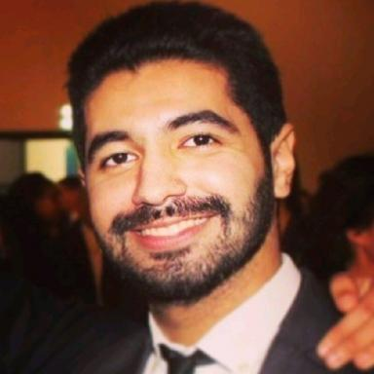 Ayoub DRISSI

Présentation

Publications

Communication dans un congrès (2)

Coupling Prognostics and Decision Making (P&DM) processes in PHM: A literature review and proposal of a residual performance lifetime concept
Ayoub Drissi,Benoît Iung,Alexandre Voisin,Vincent Galinier
5th IFAC Workshop on Advanced Maintenance Engineering, Services and Technology, AMEST 2022, Jul 2022, Bogota, Colombia. pp.145-150, ⟨10.1016/j.ifacol.2022.09.198⟩
Communication dans un congrès
hal-03785948v1
Industrial system functioning/dysfunctioning-based approach for indicator identification to support proactive maintenance
Thomas Laloix,Alexandre Voisin,Salah Deeb,Eric Romagne,Benoît Iunget al.
20th IFAC World Congress, IFAC 2017, Jul 2017, Toulouse, France
Communication dans un congrès
hal-01567882v1

