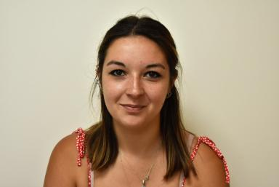 Béryle Lecomte Assistante Ingénieure en Protocoles et Analyses Biologiques

Identifiants chercheurs

- IdHAL : beryle-lecomte
- ORCID : 0000-0002-2759-0501

Publications

Article dans une revue (1)

Postprandial lipid and vascular responses following consumption of a commercially-relevant interesterified palmitic acid-rich spread in comparison to functionally-equivalent non-interesterified spread and spreadable butter: a randomised controlled trial in healthy adults
Wendy Hall,Aseel Alkoblan,Philippa Gibson,Maria d'Annibale,Astrid Coekaertset al.
Food and Function, 2024, 15 (5), pp.2733-2750. ⟨10.1039/d3fo05324e⟩
Article dans une revue
hal-04600778v1

