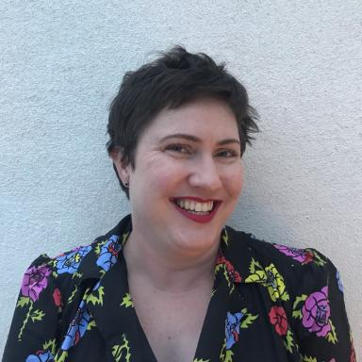 Bethany QUALLS Chercheuse post-doctorante, Punch's Pocket Book Archive

Identifiants chercheurs

- IdHAL :
bethany-qualls
- ORCID :
0000-0002-3312-7791

Publications

Article dans une revue (2)

Gossip’s ephemeral longevity: Power, circulation, and new media
Bethany E. Qualls
Necsus - European Journal of Media Studies, 2022, 11 (1), pp.41-66. ⟨10.25969/mediarep/18836⟩
Article dans une revue
hal-05268742v1
WWA Reflection: Continuing to #WriteWithAphra
Bénédicte Miyamoto,Ashley Bender,Daniella Berman,Jenny Factor,Elizabeth Giardinaet al.
ABO: Interactive Journal for Women in the Arts, 1640-1830 , 2021, 11 (2), pp.17. ⟨10.5038/2157-7129.11.2.1285⟩
Article dans une revue
hal-03818307v1

Communication dans un congrès (4)

Uncommon Fame, Reputation Transitions, and Information Shifts in Richardson’s &lt;i&gt;Clarissa&lt;/i&gt;
Bethany E. Qualls
64e Congrès de la SAES : Transitions induites par l’Intelligence Artificielle dans la recherche en anglistique Atelier XVII-XVIII, Université Toulouse Jean Jaurès; Société des Anglicistes de l'Enseignement Supérieur, Jun 2025, Toulouse, France
Communication dans un congrès
hal-05512164v1
Have Cats Always Been Memes? The Prevalence of Signifying Felines in Imagetexts from the 1700s to Today
Bethany E. Qualls
ASECS 2025: 55th Annual Meeting, American Society for Eighteenth-Century Studies (ASECS), Mar 2025, Online (virtual conference), United States
Communication dans un congrès
hal-05512192v1
Visions of Pocket Technology: Materiality as Digital Practice with the &lt;i&gt;Punch’s Pocket Book&lt;/i&gt; Archive Project
Bethany E. Qualls
RSVP "Voices and Visions of the Nineteenth-Century Periodical Press" pre-conference event: Representation and Remediation in Victorian Periodicals, Research Society for Victorian Periodicals (RSVP), Jun 2025, Online (virtual conference), France
Communication dans un congrès
hal-05512208v1
A Brief History of Pocket Books with DIY Bookbinding Session
Bethany E. Qualls
We Are Amused : Victorian Humour in the Digital Age, Punch's Pocket Book Archive; ERIBIA; MRSH, Nov 2024, Caen, France
Communication dans un congrès
hal-05512225v1

Notice d’encyclopédie ou de dictionnaire (1)

Brothels
Bethany E. Qualls
DIGIT.EN.S: The Digital Encyclopedia of British Sociability in the Long Eighteenth Century [online], 2025
Notice d’encyclopédie ou de dictionnaire
hal-05226669v1

Carte (1)

Interactive collection, William Hogarth's Harlot's Progress (1732) and Rake's Progress (1734-35)
Bethany E. Qualls
United States. 2024
Carte
hal-05268691v1

