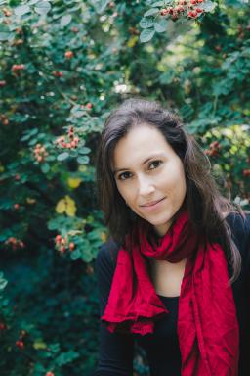 Brunna Crespi Chargée de cours (Paris 1, Gustave Eiffel)

Identifiants chercheurs

- IdHAL : brunna-crespi
- ORCID : 0009-0007-0018-4646
- cv.identifier.google scholar : https://scholar.google.fr/citations?user=qkP4ZcIAAAAJ&hl=fr

Présentation

Brunna Crespi is a research associate at UMR 208 Paloc (Local Heritage, Environment & Globalization, MNHN/IRD) and at LEEG-UNB (Laboratory for Studies on Economies and Globalization). A member of the Interdisciplinary Working Group on Indigenous Peoples (GTPA) and the Réseaux Expertes network, she combines academic expertise with a commitment to Indigenous and environmental issues.She holds a Bachelor’s degree in Biology and Ethnosciences from the University of São Paulo (Brazil) and went on to earn an interdisciplinary Master’s degree in “Environment, Development, Territories, and Societies” from the National Museum of Natural History and Paris 7 - Denis Diderot University. In 2018, she completed a PhD in Ethnology at the National Museum of Natural History, followed by a postdoctoral fellowship at the Musée du Quai Branly - Jacques Chirac (Paris).Brunna Crespi’s work is grounded in decolonial anthropology, collaborating closely with local communities in the Amazon, insular Southeast Asia, and the Pacific. Her current research focuses on oral narratives and territories, analyzing Indigenous knowledge, forms of territoriality, and socio-environmental dynamics. She examines how these processes unfold in multicultural and postcolonial contexts, aiming to produce sensitive cartographies rooted in local realities.

Publications

Article dans une revue (2)

Entre pétrole et tourisme, la conservation participative des patrimoines locaux au Timor-Leste (Timor oriental) : exemple de Suai et Ataúro (districts de Covalima et Dili)
Dominique Guillaud,Laure Emperaire,B. Crespi,R. Soares,A. Pequignotet al.
Revue d’ethnoécologie, 2017, Cartographie participative, 11, ⟨10.4000/ethnoecologie.2947⟩
Article dans une revue
ird-02069088v1
La communauté de pêcheurs de Taperebá (Amapá- Brésil) face à la création du Parc national du Cabo Orange
Brunna Crespi,Pauline Laval,Catherine Sabinot
Espace Populations Sociétés, 2015, 2-3, 23 p. [en ligne]. ⟨10.4000/eps.5874⟩
Article dans une revue
hal-01829053v1

Communication dans un congrès (1)

Identités, migrations et transmission des savoirs des pêcheurs du bas-Oyapock
B. Crespi,Pauline Laval
Séminaire annuel de restitution de l’Observatoire Hommes -Milieux Oyapock, Dec 2013, Cayenne, France
Communication dans un congrès
hal-04632398v1

Thèse (1)

Sacralité, rituels et développement chez les Bunaq et Tetun de la région de Suia, Timor oriental
Brunna Crespi
Géographie. Museum national d'histoire naturelle - MNHN PARIS, 2018. Français. ⟨NNT : 2018MNHN0030⟩
Thèse
tel-02947231v1

