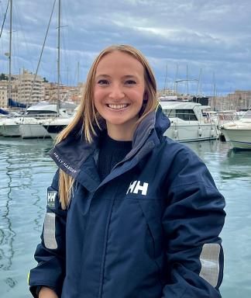 Camille Carpentier Doctorante au sein du Laboratoire MERSEA UR 7482 - Marine Ecosystems and oRganisms reSEArch Lab

Publications

Article dans une revue (7)

When coral dies but fish remain: limits of local restoration under climate pressure (Bora Bora, French Polynesia)
David Lecchini,Stéphanie Krimou,Xavier Raick,Bastien Pagli,Camille Gacheet al.
Environmental Biology of Fishes, 2026, 109 (1), pp.52. ⟨10.1007/s10641-026-01816-w⟩
Article dans une revue
hal-05558215v1
Coral degradation alters community diversity and stability of fish and invertebrate assemblages following recruitment
Jules Schligler,Megan Mcbride,Perrine Salvi,Camille Carpentier,Théo Guillaumeet al.
Marine Ecology Progress Series, 2026, 780, pp.1-10. ⟨10.3354/meps15081⟩
Article dans une revue
hal-05558129v1
Highlighting competitive interactions between algae, corals, and herbivores in Bora Bora (French Polynesia)
C. Carpentier,F. Bertucci,L. Sowinski,E. Gairin,L. Minieret al.
Marine Biology, 2025, 172 (4), pp.62. ⟨10.1007/s00227-025-04628-1⟩
Article dans une revue
hal-05235638v1
Study of the coastal reef fishery pressure in a South Pacific Island (Bora-Bora, French Polynesia)
Hugo Gatouillat,Emma Gairin,Lana Minier,Alannah Gouarlouen,Camille Carpentieret al.
Aquatic Living Resources, 2024, 37, pp.3. ⟨10.1051/alr/2024001⟩
Article dans une revue
hal-04365327v1
Phylogeography of &lt;i&gt;Microphis retzii&lt;/i&gt; (Bleeker, 1856) and &lt;i&gt;Microphis brachyurus&lt;/i&gt; (Bleeker, 1854) in the Pacific
Vincent Haÿ,Marion I Mennesson,Camille Carpentier,Hadi Dahruddin,Sopian Sauriet al.
Journal of Fish Biology, 2024, 106, pp.602 - 620. ⟨10.1111/jfb.15981⟩
Article dans une revue
hal-05017685v1
Temporal shifts in algal and fish assemblages following the introduction of herbivorous species in coral reef patches (Bora Bora Island)
Xavier Raick,Ethel Mery,Camille Carpentier,Stéphanie Krimou,Jérome Sowinskiet al.
Journal for Nature Conservation, 2024, 82 (2), pp.126761. ⟨10.1016/j.jnc.2024.126761⟩
Article dans une revue
hal-05331956v1
Restoring the reef: Coral restoration yields rapid impacts on certain fish assemblages
Stéphanie Krimou,Xavier Raick,Ethel Mery,Jeremy Carlot,Camille Carpentieret al.
Estuarine, Coastal and Shelf Science, 2024, pp.108734. ⟨10.1016/j.ecss.2024.108734⟩
Article dans une revue
hal-04526895v1

Poster de conférence (1)

Ecodesign benefits for carbon efficiency in artificial reefs: a case study with novel monitoring methods in a windfarm-impacted area of the English Channel
Camille Carpentier,Maël Deloor,Maxime Navon,Anne-Marie Rusig,Pascal Claquin
Ocean Science Meeting (OSM), Feb 2026, Glasgow (Ecosse), France
Poster de conférence
hal-05558156v1

