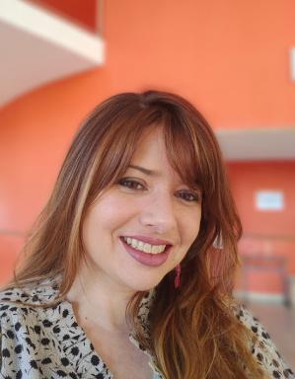 María del Carmen Heredia Martínez

Identifiants chercheurs

- IdHAL : carmen-heredia-martinez
- ORCID : 0000-0002-2713-2893
- cv.identifier.google scholar : https://scholar.google.fr/citations?user=2_bqEjAAAAAJ
- ResearcherID : KSL-9390-2024

Présentation

She currently combines her work as a professor at the University of Cádiz with research on aesthetics, arts and construction of cultural identities using digital humanities tools as methodological resources applied to research.
Doctorate in Arts and Humanities, in the line of Cultural Studies for which he obtained the International Mention, University of Cádiz (Spain), 2024.
Doctorate in Languages, Literature and Civilization from the University of Burgundy (France), 2024.

Publications

Article dans une revue (1)

Imágenes del flamenco de Realito en la Sevilla de 1929
Carmen Heredia Martínez
HUMAN REVIEW International Humanities Review, 2022, 11 (Monográfico), pp.1-14. ⟨10.37467/REVHUMAN.V11.4341⟩
Article dans une revue
hal-04733781v1

N°spécial de revue/special issue (1)

El camino de los lunares flamencos: Una aproximación a los lunares como símbolo iconográfico de lo español
María del Carmen Heredia Martínez
86, 2019, Becas de Investigación del Observatorio Cultural Atalaya
N°spécial de revue/special issue
hal-04853032v1

