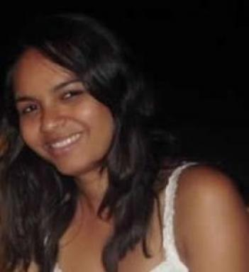 Caroline Silva

Identifiants chercheurs

- IdHAL : caroline-silva
- ORCID : 0000-0002-0777-1065

Présentation

Currently PhD student at University of La Rochelle (L3I/MIA), France.
Fields of interest: Computer Vision, Machine Learning and Pattern Recognition.

Publications

Article dans une revue (2)

On the Role and the Importance of Features for Background Modeling and Foreground Detection
Thierry Bouwmans,Caroline Silva,Cristina Marghes,Mohamed Sami Zitouni,Harish Bhaskaret al.
Computer Science Review, 2018, 28, pp.26-91. ⟨10.1016/j.cosrev.2018.01.004⟩
Article dans une revue
hal-01724317v1
Superpixel-based online wagging one-class ensemble for feature selection in foreground/background separation
Caroline Silva,Thierry Bouwmans,Carl Frelicot
Pattern Recognition Letters, 2017, 100, pp.144-151. ⟨10.1016/j.patrec.2017.10.034⟩
Article dans une revue
hal-01654502v1

Communication dans un congrès (3)

Specialised mathematical knowledge in the scope of geometric isometric transformation translation and its impact on teacher's levels of Interpretive Knowledge
Caroline Silva,Miguel Ribeiro
Proceedings of the Fourteenth Congress of the European Society for Research in Mathematics Education (CERME14), Free University of Bozen-Bolzano; ERME, Feb 2025, Bozen-Bolzano, Italy
Communication dans un congrès
hal-05290966v1
Online Weighted One-Class Ensemble for Feature Selection in Background/Foreground Separation
Caroline Silva,Thierry Bouwmans,Carl Frélicot
International Conference on Pattern Recognition, ICPR 2016, Dec 2016, Cancun, Mexico. pp.2216-2221
Communication dans un congrès
hal-01523104v1
An eXtended Center-Symmetric Local Binary Pattern for Background Modeling and Subtraction in Videos
Caroline Silva,Thierry Bouwmans,Carl Frélicot
International Joint Conference on Computer Vision, Imaging and Computer Graphics Theory and Applications, VISAPP 2015, Mar 2015, Berlin, Germany. ⟨10.5220/0005266303950402⟩
Communication dans un congrès
hal-01227955v1

