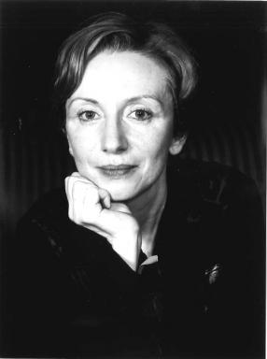 Catherine LEZON-GÄRTNER

Identifiants chercheurs

- IdHAL : catherine-lezon-gartner

Présentation

I started my higher education in the fields of science, economics and finance, where I obtained two master’s degrees and became a qualified actuary. I then carried out a professional activity in insurance supervision by public authorities, lastly in an international organization in Switzerland. Since 2019, I have been dedicating myself to literary and artistic activities, which have always been part of my major areas of interest. In 2022 I also earned a master’s degree in literature.

Publications

