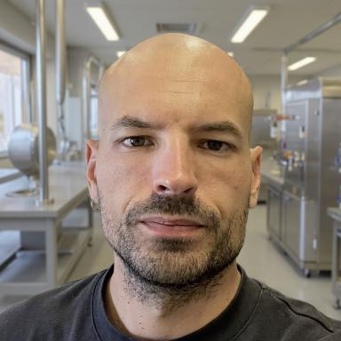 Charles Guillemard Chercheur CNRS

Identifiants chercheurs

- IdHAL :
charles-guillemard
- ORCID :
0000-0002-3347-0047

Publications

Poster de conférence (4)

Structural and magnetic characterization of Mn 100-x Sn x chiral antiferromagnets epitaxial films
Charles Guillemard,Matthieu Petit,Vasile Heresanu,Lisa Michez
Colloque Louis Néel 2025, Jun 2025, Vogüé, France
Poster de conférence
hal-05129971v1
Site-specific X-ray magnetic circular dichroism in high quality Mn3Ge ferrimagnetic epitaxial films
Charles Guillemard
10th AUSE Conference and 5th ALBA User's Meeting, Sep 2022, Barcelona, Spain
Poster de conférence
hal-05136392v1
Epitaxial Co2Mn-based Heusler alloys for spintronics : Half Metal Magnet investigation
Charles Guillemard
Journées Surfaces et Interfaces, Jan 2019, Nancy, France
Poster de conférence
hal-05136371v1
Epitaxial cobalt-based Heusler alloys investigated by spin-resolved photoemission spectroscopy, ferromagnetic resonance and X-ray diffraction
Charles Guillemard
Colloque Louis Néel, Sep 2017, Paris, France
Poster de conférence
hal-05136484v1

