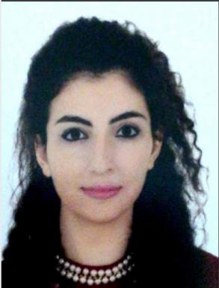 Christelle Rabbat

Identifiants chercheurs

- IdHAL : christelle-rabbat
- ORCID : 0000-0001-9776-7539
- IdRef : 271032448

Présentation

Publications

Article dans une revue (6)

Experimental study on bio-oil recovery from biobased building insulation materials and its upgrading
Ayik Abdillah,Christelle Rabbat,Sary Awad,Audrey Villot,Cindy Rianti Priadiet al.
AIP Conference Proceedings, 2024, 3001 (1), pp.020001. ⟨10.1063/5.0185966⟩
Article dans une revue
hal-05366301v1
Gaseous and Particulate matter emissions from the combustion of biomass-based insulation materials at end-of-life in a small-scale biomass heating boiler
Christelle Rabbat,Audrey Villot,Sary Awad,Yves Andres
Fuel, 2023, 338, pp.127182. ⟨10.1016/j.fuel.2022.127182⟩
Article dans une revue
hal-04594483v1
Adsorption of ibuprofen from aqueous solution onto a raw and steam-activated biochar derived from recycled textiles insulation panels at end-of-life: Kinetic, isotherm and fixed-bed experiments
Christelle Rabbat,Andrea Pinna,Yves Andres,Audrey Villot,Sary Awad
Journal of Water Process Engineering, 2023, 53, pp.103830. ⟨10.1016/j.jwpe.2023.103830⟩
Article dans une revue
hal-04808489v1
Sustainability of biomass-based insulation materials in buildings: Current status in France, end-of-life projections and energy recovery potentials
Christelle Rabbat,Sary Awad,Audrey Villot,Delphine Rollet,Yves Andres
Renewable and Sustainable Energy Reviews, 2022, 156, ⟨10.1016/j.rser.2021.111962⟩
Article dans une revue
hal-03470528v1
Towards the Production of High Added-Value Products from the Pyrolysis and Steam Pyro-Gasification of Five Biomass-Based Building Insulation Materials at End-of-Life
Christelle Rabbat,Sary Awad,Audrey Villot,Yves Andres
Waste and Biomass Valorization, 2022, ⟨10.1007/s12649-022-01989-2⟩
Article dans une revue
hal-03886265v1
A New Quick and Simple Protocol to Evaluate Microalgae Polysaccharide Composition
Antoine Decamp,Orane Michelo,Christelle Rabbat,Céline Laroche,Dominique Grizeauet al.
Marine drugs, 2021, 19 (2), ⟨10.3390/md19020101⟩
Article dans une revue
hal-03246036v2

Thèse (1)

Study of the valorization of biomass-based building materials at the end-of-life
Christelle Rabbat
Chemical and Process Engineering. Ecole nationale supérieure Mines-Télécom Atlantique, 2023. English. ⟨NNT : 2023IMTA0344⟩
Thèse
tel-04600388v1

