Christophe Lucas

Identifiants chercheurs

- IdHAL : christophe-lucas
- ORCID : 0000-0003-2839-7583
- IdRef : 074784331
- ResearcherID : A-4186-2011

Présentation

Academic
Full CV (PDF in French)
Oct. 2010- CNRS Research Scientist (section 29)University of Tours, France
2010 FNS Senio researcherUniversity of Lausanne, SuisseBehavioral genetics in the ant Solenopsis invicta
2007-09 First assistantUniversity of Lausanne, Suisse (Supervisor: Laurent Keller)Social structure and genetic expression in the ant Solenopsis invicta
2003-06 Post-doctoral researcherUniversity of Toronto, Canada (Supervisor: Marla B. Sokolowski)Molecular mecanisms of the plasticity of social behaviors in the ant Pheidole pallidula
1998-2002 Doctorat ès sciencesUniversity of Paris-Sud (Directors: Jean-Marc Jallon & Dominique Fresneau)Chemical and behavioral bases of the recognition system in the ponerine ants (Pachycondyla)
Research keywords
Research fields: Chemical ecology, behavioral ecology, behavioral genetics, adaptation
Keywords: Chemical communication, genetic expression, behavior, polyethism, polyphenism, foraging gene, social conflict, reproduction, insect societies, invasive species.
Biological models: Social insects (termite, ant, wasp), earwig, drosophila, nasonia.
Research projects
My main research projects are to understand complex behaviors of insects and particularly of social insects. How environmental factors are pursued, analyzed and which behavioral responses are influenced? But also, how intra- and interspecific interactions could modify behaviors by changing gene expression? By using tools from chemical ecology and behavioral genetics, my own researches focus on social interactions and their adaptive impacts. So, my studies are based on insect behaviors (recognition, aggressiveness, foraging, parental care, sexual courtship) through the study of chemical communications and gene expression.
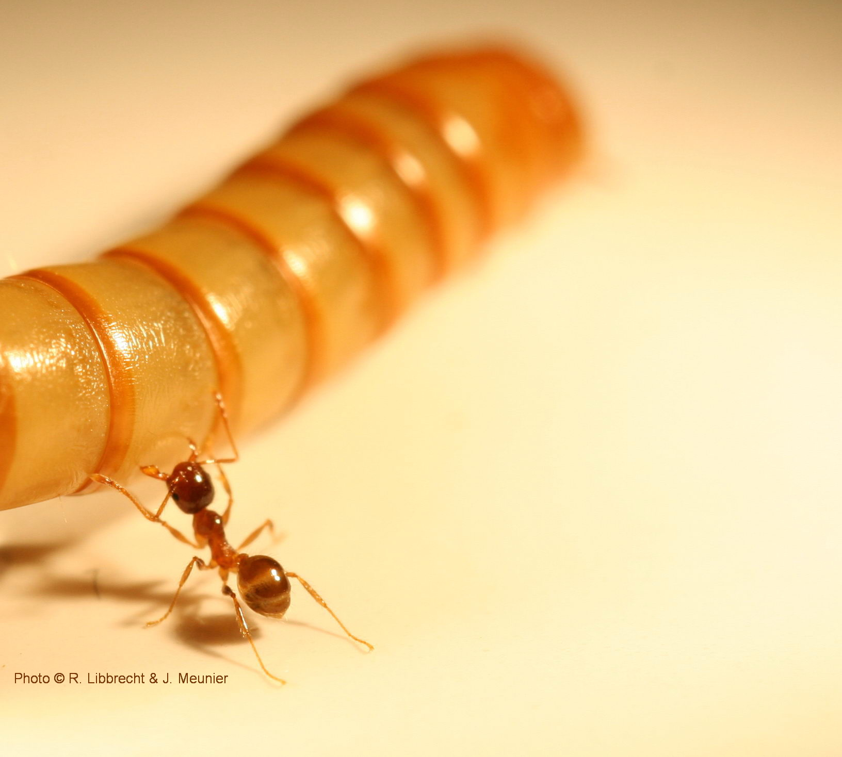
Behaviors and genes expression are under several abiotic and biotic environmental factors which also include social environment. Chemical communication plays an important role in inter-individual interaction in insects and codifies part of the environmental and social information. To unravel communication mechanisms of insects and their evolutions, it is of primary importance to decrypt such chemical information. In more details, I explore questions on behavioral plasticity of insects and in particular in social insects: What are the chemical signals and the genes involved? How environmental factors play a role? What are the consequences of the different reproductives/castes on social organization in insect societies? How such systems are maintained and evolved?
In social insects, the caste system allow the main factor influencing behavioral plasticity is the caste system which is linked to social organization and raised several questions
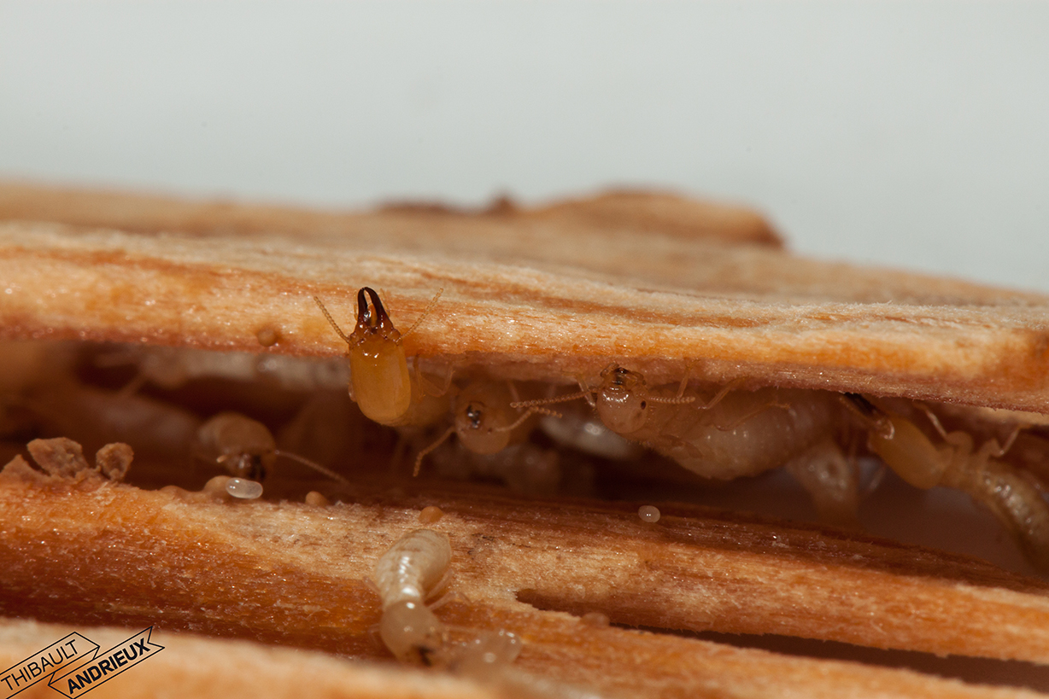
Species studied
To answers such questions, I study several insect models like termites, ants, earwigs, wasps (solitary and social) and drosophila. They all presents specificity and possess different advantages for my researches. Social insects like termites and ants are organized in complex societies with several social interactions. Nevertheless, eusociality (true sociality) appeared independently in Isopteran (termites) and Hymenopteran (ants, bees and wasps) which gives to termites unique specificities. Concerning drosophila, it is the most studied insect model and its genome is known since a long time, which allow to dissect in details the genetic pathways of its communication system.
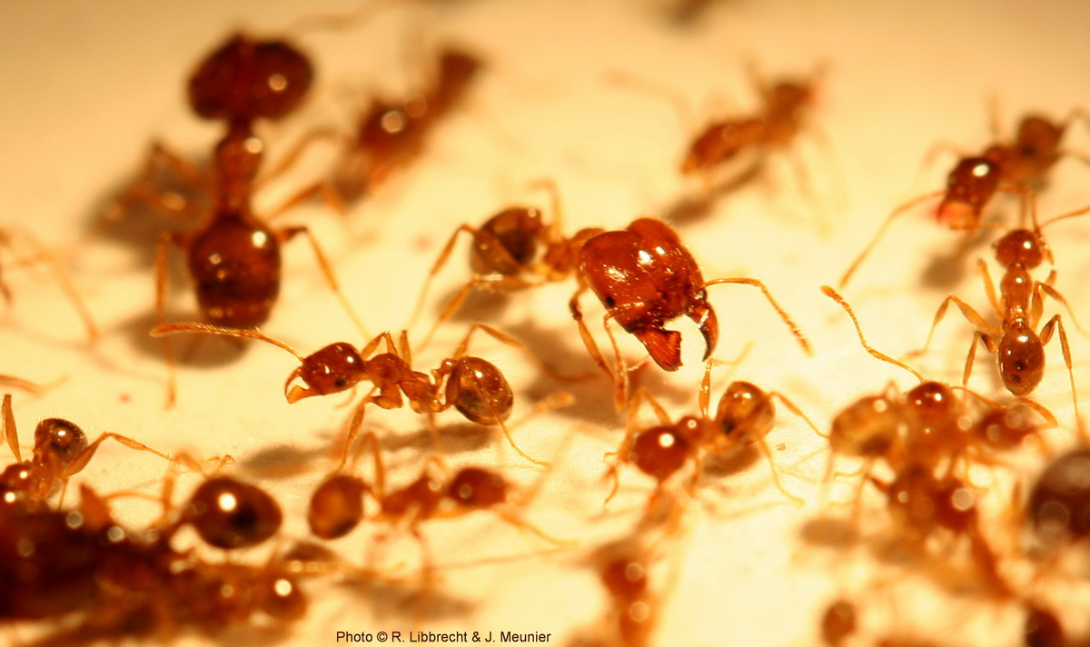
Main methods
- Chemical analyze and identification: gas chromatography (GC), mass spectrometry (GC-MS/GC-TQ), thin layer chromatography (TLC), liquid chromatography (HPLC), chemical extraction (SPME, SBSE, SHS, DHS, DMDS)- Genetic expression: quantitative RT-PCR, in situ, RNA interference- Experimental behavior: video-tracking, cross-linked reproduction, cross-fostering
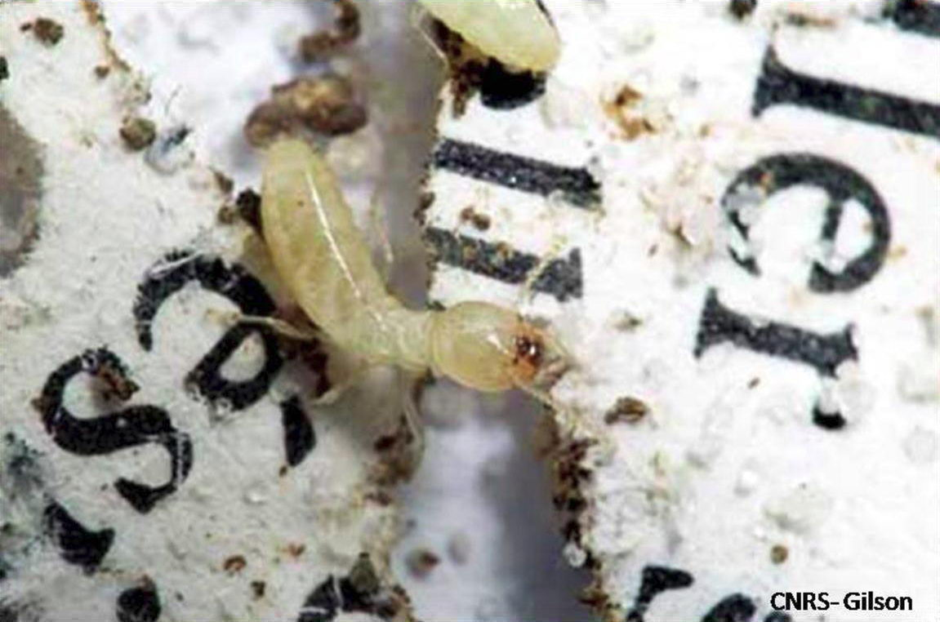
Liens
Union Internationale pour l'Etude des Insectes Sociaux - Section FrançaiseGDR d'écologie chimiqueCanadian TV news on &quot;foraging behaviour of Pheidole pallidula&quot;

Publications

Article dans une revue (32)

Repellent effect of selected essential oils against the wolf spider Pardosa hortensis (Araneae: Lycosidae)
Marek Chajduk,Marek Gołębiowski,Marzena Stańska,Christophe Lucas
Behavioural Processes, 2025, 233, pp.105283. ⟨10.1016/j.beproc.2025.105283⟩
Article dans une revue
hal-05360905v1
We are not the same: a chemical heterogeneity between workers in the Yellow-legged hornet
Mélissa Haouzi,Florian Bastin,Marie-Charlotte Cheutin,Christophe Lucas,Elfie Perdereauet al.
Chemoecology, 2024, 35, pp.11-20. ⟨10.1007/s00049-024-00413-6⟩
Article dans une revue
hal-04797440v1
Chemical profiles of venom glands in queens, foundresses, pre-wintering gynes, and workers in the hornet Vespa velutina nigrithorax
Laurence Berville,Christophe Lucas,Mélissa Haouzi,Ali Khalil,Jérémy Gévaret al.
Comptes Rendus. Chimie, 2023, pp.1-16. ⟨10.5802/crchim.228⟩
Article dans une revue
hal-04018659v1
Reproductives signature revealed by protein profiling and behavioral bioassays in termite
Fanny Ruhland,Guillaume Gabant,Timothée Toussaint,Matej Nemcic,Martine Cadèneet al.
Scientific Reports, 2023, 13 (1), pp.7070. ⟨10.1038/s41598-023-33252-6⟩
Article dans une revue
hal-04090025v1
Callows have their own odour but not for long: Fast acquisition of the chemical signature in the yellow-legged hornet, Vespa velutina nigrithorax
Mélissa Haouzi,Yanan Cheng,Laurence Berville,Christophe Lucas,Ken Tanet al.
Entomologia Generalis, In press, ⟨10.1127/entomologia/2023/2133⟩
Article dans une revue
hal-04291686v1
Defensive behavior is linked to altered surface chemistry following infection in a termite society
M. Alejandra Esparza-Mora,Tilottama Mazumdar,Shixiong Jiang,Renate Radek,Julian N. Thiemet al.
Scientific Reports, In press, 13, pp.20606. ⟨10.1038/s41598-023-42947-9⟩
Article dans une revue
hal-04288294v1
High exploration behavior of termite propagules can enhance invasiveness
Louis Pailler,Arthur Matte,Alexis Groseiller,Pierre-André Eyer,Fanny Ruhlandet al.
Frontiers in Ecology and Evolution, 2022, 10, ⟨10.3389/fevo.2022.840105⟩
Article dans une revue
hal-03641830v1
Synomones in necrophagous larvae of the blow flies &lt;i&gt;Lucilia sericata&lt;/i&gt; and &lt;i&gt;Calliphora vomitoria&lt;/i&gt;
Quentin Fouché,Damien Charabidzé,Christophe Lucas
Medical and Veterinary Entomology, 2022, ⟨10.1111/mve.12614⟩
Article dans une revue
hal-03799160v1
The foraging gene as a modulator of division of labour in social insects
Christophe Lucas,Yehuda Ben-Shahar
Journal of Neurogenetics, 2021, pp.1-11. ⟨10.1080/01677063.2021.1940173⟩
Article dans une revue
hal-03266302v1
Vibratory behaviour produces different vibration patterns in presence of reproductives in a subterranean termite species
Louis Pailler,Samuel Desvignes,Fanny Ruhland,Miguel Pineirua,Christophe Lucas
Scientific Reports, 2021, 11 (1), ⟨10.1038/s41598-021-88292-7⟩
Article dans une revue
hal-03250610v1
Worker ants promote outbreeding by transporting young queens to alien nests
Mathilde Vidal,Florian Königseder,Julia Giehr,Alexandra Schrempf,Christophe Lucaset al.
Communications Biology, 2021, 4 (1), ⟨10.1038/s42003-021-02016-1⟩
Article dans une revue
hal-03250609v1
Reproductives and eggs trigger worker vibration in a subterranean termite
Fanny Ruhland,Marion Moulin,Marina Choppin,Joël Meunier,Christophe Lucas
Ecology and Evolution, 2020, 10 (12), pp.5892-5898. ⟨10.1002/ece3.6325⟩
Article dans une revue
hal-02982089v1
Unbalanced biparental care during colony foundation in two subterranean termites
Lou Brossette,Joël Meunier,Simon Dupont,Anne-Geneviève Bagnères,Christophe Lucas
Ecology and Evolution, 2019, 9, pp.192 - 200. ⟨10.1002/ece3.4710⟩
Article dans une revue
hal-02996395v1
When predator odour makes groups stronger: effects on behavioural and chemical adaptations in two termite species
Christophe Lucas,Lou Brossette,Lauriane Lefloch,Simon Dupont,Jean-Philippe Christideset al.
Ecological Entomology, 2018, 43 (4), pp.513-524. ⟨10.1111/een.12529⟩
Article dans une revue
hal-02266508v1
Les termites s'invitent en région Centre-Val de Loire
Christophe Lucas,Fanny Ruhland
Microscoop : Un regard sur les laboratoires en Centre Limousin Poitou-Charentes (CNRS), 2018, pp.16-17
Article dans une revue
hal-02266571v1
Nest signature changes throughout colony cycle and after social parasite invasion in social wasps
Marta Elia,Giuliano Blancato,Laura Picchi,Christophe Lucas,Anne-Geneviève Bagnèreset al.
PLoS ONE, 2017, 12 (12), pp.e0190018. ⟨10.1371/journal.pone.0190018⟩
Article dans une revue
hal-02266534v1
Termite’s royal cradle: does colony foundation success differ between two subterranean species?
L. Brossette,A.-G. Bagnères,A. Millot,S. Blanchard,Simon Dupontet al.
Insectes Sociaux, 2017, 64 (4), pp.515-523. ⟨10.1007/s00040-017-0571-x⟩
Article dans une revue
hal-02266527v1
A Combined Approach to Heat Stress Effect on Male Fertility in Nasonia vitripennis: From the Physiological Consequences on Spermatogenesis to the Reproductive Adjustment of Females Mated with Stressed Males
Marlène Chirault,Christophe Lucas,Marlène Goubault,Claude Chevrier,Christophe Bressacet al.
PLoS ONE, 2015, 10 (3), pp.e0120656. ⟨10.1371/journal.pone.0120656⟩
Article dans une revue
hal-02146269v1
Paternal signature in kin recognition cues of a social insect: concealed in juveniles, revealed in adults
Janine Wong,Joël Meunier,Christophe Lucas,Mathias Kölliker
Proceedings of the Royal Society B: Biological Sciences, 2014, 281 (1793), pp.20141236. ⟨10.1098/rspb.2014.1236⟩
Article dans une revue
hal-02266540v1
Expression of foraging and Gp-9 are associated with social organization in the fire ant Solenopsis invicta
Christophe Lucas,M. Nicolas,L. Keller
Insect Molecular Biology, 2014, 24 (1), pp.93-104. ⟨10.1111/imb.12137⟩
Article dans une revue
hal-02266536v1
Recognition in ants: social origin matters
Joël Meunier,Olivier Delémont,Christophe Lucas
PLoS ONE, 2011, 6 (5), pp.e19347. ⟨10.1371/journal.pone.0019347⟩
Article dans une revue
hal-02266543v1
Les termites, un monde de castes
Éric Darrouzet,Christophe Lucas
Microscoop : Un regard sur les laboratoires en Centre Limousin Poitou-Charentes (CNRS), 2011, pp.14-15
Article dans une revue
hal-02266572v1
The locust foraging gene
Christophe Lucas,R. Kornfein,M. Chakaborty-Chatterjee,J. Schönfeld,N. Gevaet al.
Archives of Insect Biochemistry and Physiology, 2010, 74 (1), pp.52-66. ⟨10.1002/arch.20363⟩
Article dans une revue
hal-02266545v1
Job switching in ants: role of a kinase
Christophe Lucas,Bryon Hughson,Marla Sokolowski
Communicative and Integrative Biology, 2010, 3 (1), pp.6-8. ⟨10.4161/cib.3.1.9723⟩
Article dans une revue
hal-02266547v1
Molecular basis for changes in behavioral state in ant social behaviors
Christophe Lucas,Marla B. Sokolowski
Proceedings of the National Academy of Sciences of the United States of America, 2009, 106 (15), pp.6351-6356. ⟨10.1073/pnas.0809463106⟩
Article dans une revue
hal-02266551v1
Social Experience Modifies Pheromone Expression and Mating Behavior in Male Drosophila melanogaster
Joshua Krupp,Clement Kent,Jean-Christophe Billeter,Reza Azanchi,Anthony K.-C. Soet al.
Current Biology, 2008, 18 (18), pp.1373-1383. ⟨10.1016/j.cub.2008.07.089⟩
Article dans une revue
hal-02266553v1
Generalization of Courtship Learning in Drosophila Is Mediated by cis-Vaccenyl Acetate
Aki Ejima,Benjamin P.C. Smith,Christophe Lucas,Wynand van Der Goes van Naters,Carson J. Milleret al.
Current Biology, 2007, 17 (7), pp.599-605. ⟨10.1016/j.cub.2007.01.053⟩
Article dans une revue
hal-02266555v1
Sequential Learning of Pheromonal Cues Modulates Memory Consolidation in Trainer-Specific Associative Courtship Conditioning
Aki Ejima,Benjamin P.C. Smith,Christophe Lucas,Joel D. Levine,Leslie C. Griffith
Current Biology, 2005, 15 (3), pp.194-206. ⟨10.1016/j.cub.2005.01.035⟩
Article dans une revue
hal-02266559v1
Role of cuticular hydrocarbons in the chemical recognition between ant species in the Pachycondyla villosa species complex
Christophe Lucas,D.B. Pho,Jean-Marc Jallon,D. Fresneau
Journal of Insect Physiology, 2005, 51 (10), pp.1148-1157. ⟨10.1016/j.jinsphys.2005.06.003⟩
Article dans une revue
istex
hal-02266557v1
Hydrocarbon circulation and colonial signature in Pachycondyla villosa
Christophe Lucas,Dang B Pho,D. Fresneau,Jean-Marc Jallon
Journal of Insect Physiology, 2004, 50 (7), pp.595-607. ⟨10.1016/j.jinsphys.2004.04.006⟩
Article dans une revue
istex
hal-02266561v1
Hydrocarbon distribution and colony odour homogenisation in Pachycondyla apicalis
V. Soroker,Christophe Lucas,T. Simon,D. Fresneau,J. Durandet al.
Insectes Sociaux, 2003, 50 (3), pp.212-217. ⟨10.1007/s00040-003-0669-1⟩
Article dans une revue
istex
hal-02266562v1
A multidisciplinary approach to discriminating different taxa in the species complex Pachycondyla villosa (Formicidae)
Christophe Lucas,Dominique Fresneau,Kerstin Kolmer,Jürgen Heinze,Jacques H.C. Delabieet al.
Biological Journal of the Linnean Society, 2002, 75 (2), pp.249-259. ⟨10.1046/j.1095-8312.2002.00017.x⟩
Article dans une revue
hal-02266564v1

Communication dans un congrès (1)

Update on the distribution of termites and other wood-boring insects in Europe
Magdalena Kutnik,Ivan Paulmier,David Ansard,Mathilde Montibus,Christophe Lucas
International Research Group on Wood Protection, Jun 2020, Bled, Slovenia. pp.IRG/WP 20-10960
Communication dans un congrès
hal-02798137v1

Chapitre d'ouvrage (3)

Les Omiques en écologie chimique
Sylvie Baudino,Christophe Lucas,Carole Smadja
ISTE. Ecologie Chimique, , 2017, 978-1-78405-186-0
Chapitre d'ouvrage
hal-02266567v1
Omics in Chemical Ecology
Sylvie Baudino,Christophe Lucas,Carole Smadja
Chemical Ecology, John Wiley & Sons, Inc., pp.117-137, 2016, 978-1-84821-924-3
Chapitre d'ouvrage
hal-02266566v1
Odeurs en sociétés
Christophe Lucas,Marie Charpentier
Ecologie Chimique - Le Langage de la Nature, , 2012, 978-2-7491-2772-9
Chapitre d'ouvrage
hal-02266573v1

Rapport (1)

Les Cahiers Prospectives - Prospective Ecologie Chimique
Carole Smadja,Christophe Lucas,Jean Claude Caissard
[Rapport de recherche] INEE-CNRS. 2012, pp.16-23
Rapport (rapport de recherche)
hal-02266576v1

HDR (1)

Communication chez les insectes : signaux, adaptation, spécialisation
Christophe Lucas
Sciences du Vivant [q-bio]. Université de Tours / Région Centre, CR pays de la Loire, 2019
HDR
tel-02383504v1

