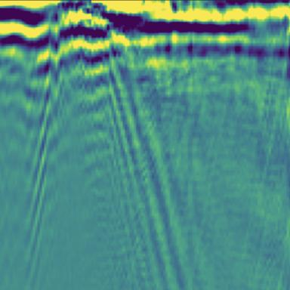 Clara Vernet PhD Student in Seismology at Géoazur, France

Publications

Article dans une revue (3)

Automatic Earthquake Catalogs From a Permanent DAS Offshore Network
Marie Baillet,Diane Rivet,Alister Trabattoni,Jérôme Chèze,Fabrice Peixet al.
Journal of Geophysical Research : Solid Earth, 2025, 130 (10), pp.e2025JB031565. ⟨10.1029/2025JB031565⟩
Article dans une revue
hal-05383475v1
Imaging the Sediment Cover Offshore Central Chile With Surface‐Wave Dispersion and P‐Wave Conversion Using Distributed Acoustic Sensing
Clara Vernet,Alister Trabattoni,Marie Baillet,Martijn van den Ende,Diane Rivet
Journal of Geophysical Research : Solid Earth, 2025, 130 (7), pp.e2024JB030507. ⟨10.1029/2024jb030507⟩
Article dans une revue
hal-05157073v1
Sediment Corrections for Distributed Acoustic Sensing
Alister Trabattoni,Clara Vernet,Martijn P.A. van den Ende,Marie Baillet,Bertrand Potinet al.
Journal of Geophysical Research : Solid Earth, 2024, 129 (10), pp.e2024JB029054. ⟨10.1029/2024JB029054⟩
Article dans une revue
hal-04721418v1

Poster de conférence (2)

Determination of the shallow S-wave velocity structure and sedimentary thickness offshore central Chile using distributed acoustic sensing
Clara Vernet,Alister Trabattoni,Marie Baillet,Diane Rivet
EGU General Assembly 2024, Apr 2024, Vienne, Austria. 2025, ⟨10.5194/egusphere-egu24-16682⟩
Poster de conférence
hal-04910936v1
A workflow for building an automatic earthquake catalog from near-real time DAS data recorded on offshore telecommunications cable in central Chile.
Marie Baillet,Alister Trabattoni,Martijn van den Ende,Clara Vernet,Diane Rivet
EGU, Apr 2024, Vienna (Austria), Austria. 2024, ⟨10.5194/egusphere-egu24-10668⟩
Poster de conférence
hal-04920470v1

