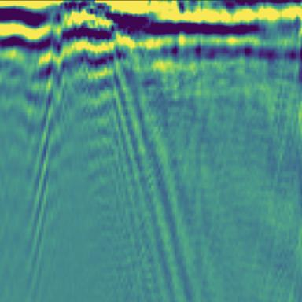 Clara Vernet PhD Student in Seismology at Géoazur, France

Publications

Article dans une revue (3)

Imaging the Sediment Cover Offshore Central Chile With Surface‐Wave Dispersion and P‐Wave Conversion Using Distributed Acoustic Sensing
Clara Vernet,Alister Trabattoni,Marie Baillet,Martijn van den Ende,Diane Rivet
Journal of Geophysical Research : Solid Earth, 2025, 130 (7), pp.e2024JB030507. ⟨10.1029/2024jb030507⟩
Article dans une revue
hal-05157073v1
Automatic Earthquake Catalogs From a Permanent DAS Offshore Network
Marie Baillet,Diane Rivet,Alister Trabattoni,Jérôme Chèze,Fabrice Peixet al.
Journal of Geophysical Research : Solid Earth, 2025, 130 (10), pp.e2025JB031565. ⟨10.1029/2025JB031565⟩
Article dans une revue
hal-05383475v1
Sediment Corrections for Distributed Acoustic Sensing
Alister Trabattoni,Clara Vernet,Martijn P.A. van den Ende,Marie Baillet,Bertrand Potinet al.
Journal of Geophysical Research : Solid Earth, 2024, 129 (10), pp.e2024JB029054. ⟨10.1029/2024JB029054⟩
Article dans une revue
hal-04721418v1

Poster de conférence (2)

Determination of the shallow S-wave velocity structure and sedimentary thickness offshore central Chile using distributed acoustic sensing
Clara Vernet,Alister Trabattoni,Marie Baillet,Diane Rivet
EGU General Assembly 2024, Apr 2024, Vienne, Austria. 2025, ⟨10.5194/egusphere-egu24-16682⟩
Poster de conférence
hal-04910936v1
A workflow for building an automatic earthquake catalog from near-real time DAS data recorded on offshore telecommunications cable in central Chile.
Marie Baillet,Alister Trabattoni,Martijn van den Ende,Clara Vernet,Diane Rivet
EGU, Apr 2024, Vienna (Austria), Austria. 2024, ⟨10.5194/egusphere-egu24-10668⟩
Poster de conférence
hal-04920470v1

