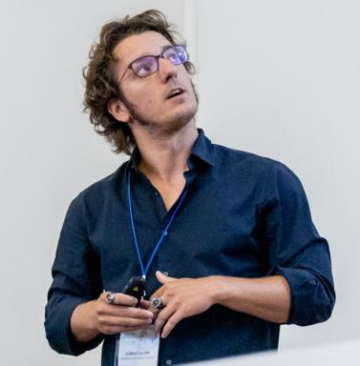 Clément Calvino Maître de Conférences à l'Université de Caen Normandie

Identifiants chercheurs

- IdHAL : clement-calvino

Publications

Article dans une revue (5)

A study of the wave effects on the current circulation in Galway Bay, using the numerical model COAWST
Clément Calvino,Tomasz Dabrowski,Frederic Dias
Coastal Engineering, 2023, 180, pp.104251. ⟨10.1016/j.coastaleng.2022.104251⟩
Article dans une revue
hal-03971995v1
Model and method to predict the turbulent kinetic energy induced by tidal currents, application to the wave-induced turbulence
Clément Calvino,Lucille Furgerot,Emmanuel Poizot,Pascal Bailly Du Bois,Anne-Claire Bennis
Renewable Energy, 2023, 216, pp.119024. ⟨10.1016/j.renene.2023.119024⟩
Article dans une revue
hal-04178307v1
Theoretical and applied considerations in depth-integrated currents for third-generation wave models
Clément Calvino,Tomasz Dabrowski,Frederic Dias
AIP Advances, 2022, 12 (1), pp.015017. ⟨10.1063/5.0077871⟩
Article dans une revue
hal-03972110v1
Current interaction in large-scale wave models with an application to Ireland
Clément Calvino,Tomasz Dabrowski,Frederic Dias
Continental Shelf Research, 2022, 245, pp.104798. ⟨10.1016/j.csr.2022.104798⟩
Article dans une revue
hal-03972042v1
A study of the sea level and current effects on the sea state in Galway Bay, using the numerical model COAWST
Clément Calvino,Tomasz Dabrowski,Frédéric Dias
Ocean Dynamics, 2022, 72 (11-12), pp.761-774. ⟨10.1007/s10236-022-01532-w⟩
Article dans une revue
hal-03972008v1

Communication dans un congrès (1)

Estimation and characterisation of the wave-induced turbulent kinetic energy and turbulent dissipation from ADCP data
Clément Calvino,Anne-Claire Bennis,Lucille Furgerot,P. Bailly Du Bois,Emmanuel Poizot
15th European Wave and Tidal Energy Conference 2023, Sep 2023, Bilbao, Spain. ⟨10.36688/ewtec-2023-299⟩
Communication dans un congrès
hal-04204521v1

Thèse (1)

Coupled wave-ocean models: An application to Galway Bay
Clément Calvino
Oceanography. UCD, 2021. English. ⟨NNT : ⟩
Thèse
tel-03972524v1

