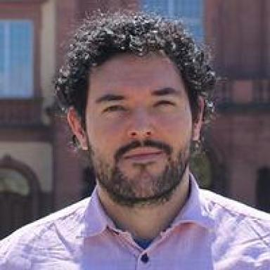 Cristian Edel Weiss Lecturer at the University of Mannheim, Chair of Political Science, International RelationsPhD Candidate at the Graduate School of Social Sciences, University of Mannheim

Identifiants chercheurs

- IdHAL : cristian-edel-weiss
- ORCID : 0009-0007-0815-5153
- ResearcherID : KGQ-6005-2024

Présentation

Lecturer at the University of Mannheim, Chair of Political Science, International Relations
Courses taught:Human Rights in International Relations - Proseminar - BA Political Science - Fall 2025
PhD Candidate at the Graduate School of Social Sciences, University of Mannheim
https://cristianweiss.com/en/
https://scholar.google.com/citations?user=IGXx2c8AAAAJ
https://www.google.de/books/edition/Transparency_in_Education_in_the_Bolsona/fv4n0QEACAAJ
https://www.uni-mannheim.de/gess/programs/cdss/our-students/2024/cristian-edel-weiss/
https://www.sowi.uni-mannheim.de/carey/team/academic-staff-and-phd-candidates/weiss-cristian/#c394751

Publications

