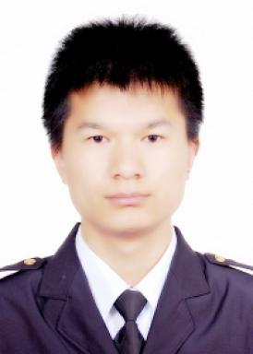 Daogui TANG

Présentation

Publications

Article dans une revue (2)

Securing demand-response in smart grids against false pricing attacks
Daogui Tang,Josep M Guerrero,Enrico Zio
Energy Reports, 2024, 12, pp.892-905. ⟨10.1016/j.egyr.2024.06.068⟩
Article dans une revue
hal-04835535v1
Resilience of Smart Power Grids to False Pricing Attacks in the Social Network
Daogui Tang,Yi-Ping Fang,Enrico Zio,José Emmanuel Ramirez-Marquez
IEEE Access, 2019, 7, pp.80491-80505. ⟨10.1109/ACCESS.2019.2923578⟩
Article dans une revue
hal-02431391v1

Communication dans un congrès (3)

A zero-sum Markov defender-attacker game for modeling false pricing in smart grids and its solution by multi-agent reinforcement learning
Daogui Tang,Yiping Fang,Enrico Zio
29th European Safety and Reliability Conference (ESREL2019), Sep 2019, Hannover, Germany. ⟨10.3850/978-981-11-2724-3-0743-cd⟩
Communication dans un congrès
hal-02303650v1
The energy management and optimization strategy for fuel cell hybrid ships
Daogui Tang,Enrico Zio,Yupeng Yuan,Jiangbin Zhao,Xinping Yan
2nd International Conference on System Reliability and Safety (ICSRS), Dec 2017, Milano, Italy
Communication dans un congrès
hal-01769600v1
Analysis of the Vulnerability of Smart Grids to Social Network-Based Attacks
Daogui Tang,Yiping Fang,Enrico Zio,José Emmanuel Ramirez-Marquez
2018 3rd International Conference on System Reliability and Safety (ICSRS), Nov 2018, Barcelona, France. pp.130-134
Communication dans un congrès
hal-02156515v1

Chapitre d'ouvrage (1)

Slab-on-grade: Chaponost
François de Larrard,Eric Garcia-Diaz,Daogui Tang,Caroline de Sa,Farid Benboudjemaet al.
Concrete Recycling Research and Practice, 1st Edition, 2019, 9781351052825. ⟨10.1201/9781351052825-30⟩
Chapitre d'ouvrage
hal-04425681v1

Thèse (1)

A simulation-based modeling framework for the analysis and protection of smart grids against false pricing attacks
Daogui Tang
Computer Science [cs]. Centrale Supélec, 2021. English. ⟨NNT : ⟩
Thèse
tel-04400491v1

