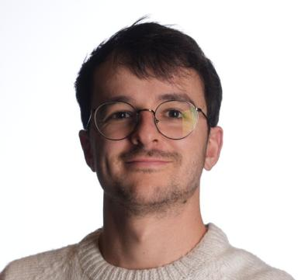 David LOISEAUX

Identifiants chercheurs

- IdHAL : david-loiseaux
- ORCID : 0009-0003-5559-3712
- arXiv : loiseaux_d_1

Publications

Article dans une revue (2)

Multi-parameter Module Approximation: an efficient and interpretable invariant for multi-parameter persistence modules with guarantees
David Loiseaux,Mathieu Carrière,Andrew Blumberg
Journal of Applied and Computational Topology, 2025, 9 (4), pp.26. ⟨10.1007/s41468-025-00222-y⟩
Article dans une revue
hal-03689199v2
multipers: Multiparameter Persistence for Machine Learning
David Loiseaux,Hannah Schreiber
Journal of Open Source Software, 2024, 9 (103), pp.6773. ⟨10.21105/joss.06773⟩
Article dans une revue
hal-04801544v1

Communication dans un congrès (4)

T-REGS: Minimum Spanning Tree Regularization for Self-Supervised Learning
Julie Mordacq,David Loiseaux,Vicky Kalogeiton,Steve Oudot
NeurIPS 2025 - Annual Conference on Neural Information Processing Systems, Dec 2025, San Diego (CA), United States
Communication dans un congrès
hal-05433730v1
Differentiability and Optimization of Multiparameter Persistent Homology
Luis Scoccola,Siddharth Setlur,David Loiseaux,Mathieu Carrière,Steve Oudot
ICML 2024 - The Forty-First International Conference on Machine Learning, Jul 2024, Wien, Austria
Communication dans un congrès
hal-04609272v1
A Framework for Fast and Stable Representations of Multiparameter Persistent Homology Decompositions
David Loiseaux,Mathieu Carrière,Andrew J. Blumberg
NeurIPS 2023 - 36th Conference on Neural Information Processing Systems, Dec 2023, New Orleans (LA), United States
Communication dans un congrès
hal-04135811v1
Stable Vectorization of Multiparameter Persistent Homology using Signed Barcodes as Measures
David Loiseaux,Luis Scoccola,Mathieu Carrière,Magnus Bakke Botnan,Steve Oudot
NeurIPS 2023 - 36th Conference on Neural Information Processing Systems, Dec 2023, New Orleans (LA), United States
Communication dans un congrès
hal-04133009v1

Thèse (1)

Multiparameter topological persistence for machine learning
David Loiseaux
Computational Geometry [cs.CG]. Université Côte d'Azur, 2024. English. ⟨NNT : 2024COAZ4051⟩
Thèse
tel-04987893v1

