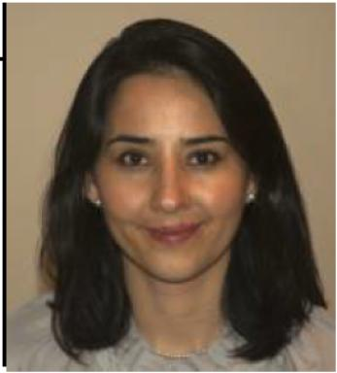 Diana Paola MORENO ALARCON

Identifiants chercheurs

- IdHAL : diana-paola-moreno-alarcon
- ORCID : 0000-0003-1697-315X
- cv.identifier.google scholar : https://scholar.google.com/citations?user=l3UbHAcAAAAJ&hl=en
- ResearcherID : 57202351913

Présentation

Publications

Article dans une revue (1)

Benefits of systems thinking for a human and organizational factors approach to safety management
Jean-François Vautier,Nicolas Dechy,Thierry Coye de Brunélis,Diana Paola Moreno Alarcon,Guillaume Hernandezet al.
Environment Systems and Decisions, 2018, 38 (3), pp.353-366. ⟨10.1007/s10669-018-9692-7⟩
Article dans une revue
hal-02290981v1

Chapitre d'ouvrage (2)

Applying Safety Leadership and Systems Thinking to the Formal and Informal Controls Approach Used in Safety and Risk Management Within the French Nuclear Sector
Diana Paola Moreno Alarcon,Jean François Vautier,Guillaume Hernandez,Franck Guarnieri
In: Kantola J., Nazir S. (eds) Advances in Human Factors, Business Management and Leadership. AHFE 2019. Advances in Intelligent Systems and Computing, vol 961. Springer, Cham, pp.481-492, 2020
Chapitre d'ouvrage
hal-02291060v1
Averting Inadequate Formulations During Cause Analysis of Unwanted Events
Jean-François Vautier,Guillaume Hernandez,Catherine Sylvestre,Diana Paola Moreno Alarcon,Isabelle Barnabéet al.
In: Bagnara S., Tartaglia R., Albolino S., Alexander T., Fujita Y. (eds) Proceedings of the 20th Congress of the International Ergonomics Association (IEA 2018). IEA 2018. Advances in Intelligent Systems and Computing, vol 819. Springer, Cham, pp.607-612, 2019
Chapitre d'ouvrage
hal-02291079v1

