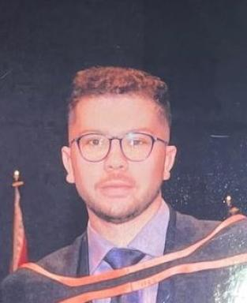 El Mehdi Laamarti

Présentation

I am El Mehdi Laamarti, currently persuing a cotutelle Ph.D. program with Queen's University and IMT Mines Alès. My research focuses on conducting experimental and computational (CFD) investigations into near-field overpressure, blast shock waves, and ground loading resulting from Boiling Liquid Expanding Vapor Explosion (BLEVE) events. My academic background includes a bilingual double degree Diplome d’ingenieur in aerospace engineering from the French grande école d'ingénieur, Ecole Polytechnique, and Concordia University in Canada (Meng Aerospace).I have further honed my expertise through academic pursuits at various Canadian institutions such as McGill, ÉTS, and Sherbrooke University. Additionally, I have gained practical experience by contributing to diverse projects in collaboration with companies/industries (Pratt and Whitney, Canadian space agency, Aramco...) and laboratories (CNRS), addressing challenges in aerospace, motorization, and energy domains.My fervor lies in sharing my passion, experiences, and knowledge to actively contribute towards overcoming challenges in the industry. I am eager to collaborate and apply my expertise in the pursuit of solutions for today's complex industrial issues.

Publications

Communication dans un congrès (2)

Experimental Investigation of the Influence of Opening Dynamics on the Blast Overpressure Anisotropy in BLEVEs
El Mehdi Laamarti,Frederic Heymes,Clément Chanut,Michael Birk
Loss Prevention 2025 - 18th International Symposium on Loss Prevention and Safety Promotion in the Process Industries, Jun 2025, Bologne, Italy. ⟨10.3303/CET25116071⟩
Communication dans un congrès
hal-05114819v1
Near-field Aerial Overpressure and Impulse from Small-scale BLEVE
El Mehdi Laamarti,A.M. Birk,Frederic Heymes
ISHPMIE 2024 - 15th International Symposium on Hazards, Prevention and Mitigation of Industrial Explosions, Jun 2024, Naples, Italy
Communication dans un congrès
hal-04615483v1

Article dans une revue (4)

Investigating overpressure BLEVE effects on 100 % liquid full vessel
El Mehdi Laamarti,A.M. Birk,Clément Chanut,Frederic Heymes
Process Safety and Environmental Protection, 2025, 199, pp.107191. ⟨10.1016/j.psep.2025.107191⟩
Article dans une revue
hal-05068763v1
Correlations to estimate the ground loading from small scale propane BLEVE experiments
El Mehdi Laamarti,A.M. Birk,Clément Chanut,Frederic Heymes
Process Safety and Environmental Protection, 2024, 185, pp.876-889. ⟨10.1016/j.psep.2024.03.006⟩
Article dans une revue
hal-04521660v1
Consequences of partial vessel failure in BLEVE and liquid full fill rupture events
El Mehdi Laamarti,Frederic Heymes,A.M. Birk
Chemical Engineering Transactions, 2024, 111, pp.331-336. ⟨10.3303/CET24111056⟩
Article dans une revue
hal-04725814v1
Small-scale BLEVE: Near-field aerial shock overpressure and impulse
E.M. Laamarti,A.M. Birk,Frederic Heymes
Journal of Loss Prevention in the Process Industries, 2024, 92, pp.105463. ⟨10.1016/j.jlp.2024.105463⟩
Article dans une revue
hal-04753091v1

