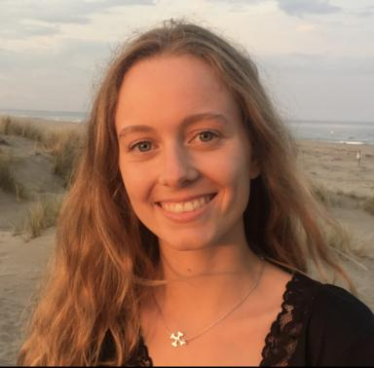 Eole Lapeyre Doctorante en sciences cognitives

Identifiants chercheurs

- IdHAL : eole-n-lapeyre
- ORCID : 0009-0000-4322-511X
- cv.identifier.google scholar : https://scholar.google.fr/citations?user=mzBGEXQAAAAJ

Présentation

My doctoral research focuses on the psycholinguistic aspects of reading in individuals with central field loss (CFL). Using eye-tracking, I explore how psycholinguistic parameters, such as predictability and word neighborhood affect reading processes in this low-vision population. The aim of my research is to help develop text simplification adapted to CFL to enhance reading accessibility, addressing a common clinical challenge. My 3-year PhD fellowship is funded by the French Ministry of Higher Education and Research.

Publications

Article dans une revue (2)

Beneficial influence of in-context predictability when young adults read with a simulated central scotoma
Eole Lapeyre,Núria Gala,Aurélie Calabrèse
Journal of Vision, 2025, 25 (7), pp.8. ⟨10.1167/jov.25.7.8⟩
Article dans une revue
hal-05263814v1
Pulsed lighting for adults with Dyslexia: very limited impact, confined to individuals with severe reading deficits
Eole Lapeyre,Jean-Baptiste Melmi,Pascale Colé,Aurélie Calabrèse
Scientific Reports, 2024, 14 (1), pp.22320. ⟨10.1038/s41598-024-73273-3⟩
Article dans une revue
hal-04816297v1

Thèse (1)

Adapting to eccentric reading: visual and psycholinguistic constraints under simulated and pathological central visual field loss
Eole Lapeyre
Cognitive science. Aix Marseille University, 2025. English. ⟨NNT : ⟩
Thèse
tel-05570026v1

Poster de conférence (3)

Comparison of two orthographic similarity measures when reading with a simulated central scotoma
Eole Lapeyre,Livia Cabasson,Núria Gala,Aurelie Calabrese
Vision Research Network (GDR Vision) 2024, Feb 2024, Grenoble, France
Poster de conférence
hal-05263850v1
Effect of word orthographic similarity when reading with a simulated central scotoma
Eole Lapeyre,Livia Cabasson,Núria Gala,Aurelie Calabrese
2024 ARVO Annual Meeting, May 2024, Seattle (USA), United States. Investigative Ophthalmology & Visual Science, 65 (7), pp.1113
Poster de conférence
hal-05046998v1
Effect of word predictability on reading performance in normally sighted readers with a simulated scotoma
Eole Lapeyre,Livia Cabasson,Carlos Aguilar,Françoise Vitu,Nuria Galaet al.
2023 ARVO Meeting, Apr 2023, New Orleans, United States. Investigative Ophthalmology & Visual Science, 64 (8), pp.2803
Poster de conférence
hal-05263838v1

