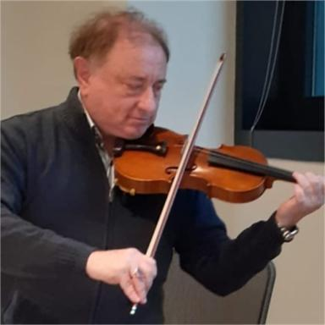 Fabrizio Tamburini Chief Quantum Officer CTO à Rotonium Edge Photonic Quantum Computers www.rotonium.com

Identifiants chercheurs

- IdHAL : fabrizio-tamburini
- ORCID : 0000-0003-2941-1922

Présentation

Born in Venice, Italy, in 2018 he was awarded the Ångström Lecture in Uppsala, Sweden, supported by the Royal Swedish Academy of Sciences and the Nobel Institute for Physics, with the motivation: “For the world-leading excellence of his scientific contribution in the field of twisted light”.
Already in 2011, his experiments on twisted radio waves set a milestone in telecommunications by showing the possibility of multiplying the transmission channels in the same frequency band of a radio link with twisted radio waves, with a successful public demonstration in Venice.This set of scientific contributions triggered, and is more and more triggering, the scientific and technological research in several fields of knowledge all around the world, with practical applications to modern technology, including telecommunications beyond the 5G protocol. The major telecom companies in the world are including these scientific contributions to develop future wireless transmissionshttps://iopscience.iop.org/article/10.1088/1367-2630/14/3/033001/meta
His studies on twisted waves are totally changing the vision of observational astronomy and astrophysics discovering a new general relativistic effect, proving that rotating black holes twist the light passing nearby, a novel application to Einstein’s general relativity https://www.nature.com/articles/nphys1907.This novel effect found an experimental confirmation from the data of Event Horizon Telescope, measuring the rotation of that monster black hole. in the galaxy M87 with twisted waves, demonstrating the validity of his theoretical and experimental approach for a new astronomy with twisted light recently published in the Monthly Notices of the Royal Astronomical Society https://academic.oup.com/mnrasl/article-abstract/492/1/L22/5645245?redirectedFrom=fulltext
He has more than two hundred scientific contributions including a monograph and book chapters, six patents, pending and accepted, that can be found in Researchgate and/or in Google Scholar.
https://www.researchgate.net/profile/Fabrizio_Tamburinihttps://scholar.google.it/citations?user=D3xxldEAAAAJ&hl=it
and dozens of invited talks, conferences and seminars in international symposia and research institutions. He is referee and member of the Editorial board of several international scientific journals.His research was presented in hundreds of interviews in scientific journals and local and international newspapers such as Nature news and views, New Scientist, Scientific american, Wired, Physics World and many other scientific magazines and highlighted in Astronomy and Astrophysics.The studies on twisted waves were also discussed in Radio and TV interviews and programs such as RAI TV Scientific news Leonardo with interviews in international radio, TV and internet programs.
He funded in 2021 with Dott. Roberto Siagri the Quantum Computing CompanyRotonium - Edge Photonic Quantum Computers at room temperature with photonic Orbital Angular Momentumwww.rotonium.com
(He usually plays his French Violin Jean-Baptiste Vuillaume à Paris / 46 rue Croix-des-Petits-Champs)

Publications

