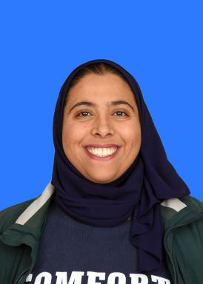 fairouz salameh Doctorante en Sociologie, Aix-Marseille Université – LEST (Laboratoire d'Économie et de Sociologie du Travail)

Identifiants chercheurs

- IdHAL : fairouz-salameh
- ORCID : 0009-0005-6304-8073

Présentation

Fairouz Salameh is a recently enrolled PhD Candidate in Sociology at Aix-Marseille Université, affiliated with LEST (Laboratoire d’Économie et de Sociologie du Travail). She holds an M.A. in Israeli Studies and a B.A. in Geography and Political Science from Birzeit University (Palestine). Her doctoral studies, starting in October 2025, will focus on settler-colonial urbanism, political geography, and the everyday life of Palestinian communities under occupation, with particular attention to border villages adjacent to Israeli settlements. She plans to combine qualitative and spatial approaches, including ethnography, oral history, and GIS analysis, to examine how colonial infrastructures shape social, political, and economic practices in Palestine.

Publications

Thèse (1)

القرى الحدودية الفلسطينية: عرب أكثر، أسعار أقل
Fairouz Salameh
Humanities and Social Sciences. Birzeit University – Program of Israeli Studies (Palestine), 2024. Arabic. ⟨NNT : ⟩
Thèse
tel-05238809v1

