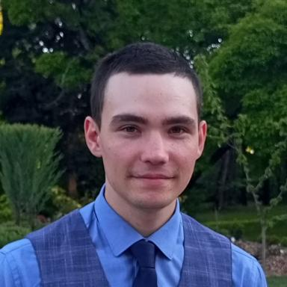 Fedor GRITSEV Master's student in the Economics, Data and Decision Science program at the Saint-Étienne School of Economics.

Identifiants chercheurs

- IdHAL : fedor-gritsev

Publications

