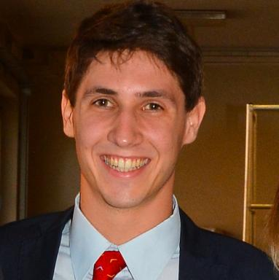 Filippo Sirianni Doctorant

Publications

