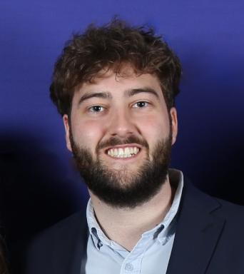 Florian DELAPLACE PhD Candidate – Biomechanics & AILAMHESS - CHU NiceTitle : Markerless Motion Analysis & AI for Characterizing Gait and Age-Related Locomotor DeclineResearch focus : leveraging optimized markerless motion analysis and AI to develop and validate composite movement biomarkers that outperform traditional indicators in assessing locomotor aging.

Identifiants chercheurs

- IdHAL : florian-delaplace
- ORCID : 0009-0005-9139-7684

Publications

Communication dans un congrès (1)

Comparison of Jump Characteristics Using an IMU and GPS-Based Sensor: Pilot Study on Three Eventing Horses
Lauriane Fayaubot,Nathalie Crevier-Denoix,Lotte Kraus,Florian Delaplace,Philippe Pourcelot
EQUIA Sciences équines et Intelligence Artificielle, EFREI, May 2025, Villejuif, France
Communication dans un congrès
hal-05577747v1

Article dans une revue (1)

The sub-base of an artificial turf rugby field has an effect on the vertical loading rate during impact
Florian Delaplace,Philippe Pourcelot,Lauriane Fayaubot,Nathalie Crevier-Denoix
Multidisciplinary Biomechanics Journal, 2025, 49th congress of the Société de Biomécanique, ⟨10.46298/mbj.14573⟩
Article dans une revue
hal-04738066v2

