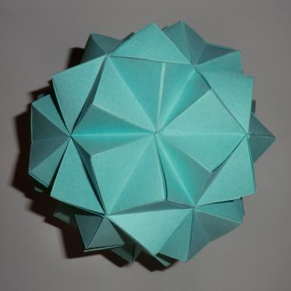 Franck Ramaharo

Identifiants chercheurs

- IdHAL :
franck-ramaharo
- ORCID :
0000-0003-0340-170X

Publications

Pré-publication, Document de travail (14)

Energy import dependence in Madagascar: A decoupling analysis
Franck Ramaharo,Rija Randriamanantena
2026
Pré-publication, Document de travail
hal-05521371v1
The bracket polynomial of the Celtic link shadow $CK_4^{2n}$
Franck Ramaharo
2025
Pré-publication, Document de travail (preprint/prepublication)
hal-05209475v1
The macroeconomic determinants of renewable energy consumption in Madagascar: Evidence from an Autoregressive Distributed Lag modeling approach
Franck M. Ramaharo,Yves H. Razanajatovo
2024
Pré-publication, Document de travail
hal-04471807v1
LMDI decomposition and macroeconomic drivers of electricity intensity in Madagascar
Franck Maminirina Ramaharo
2024
Pré-publication, Document de travail
hal-04615683v1
Does economic growth drive energy consumption in Madagascar? Fresh empirical evidence
Franck Ramaharo
2024
Pré-publication, Document de travail
hal-04691564v1
Nowcasting Madagascar's GDP growth: a machine learning approach
Gerzhino H. Rasolofomanana,Franck Ramaharo
2023
Pré-publication, Document de travail
hal-04164610v1
Les modèles macroéconomiques en usage à Madagascar
Franck Ramaharo,Yves H. Razanajatovo,Emanuella M. Aljaona
2023
Pré-publication, Document de travail
hal-04174445v1
Determinants of renewable energy consumption in Madagascar: Evidence from feature selection algorithms
Franck M. Ramaharo,Michael Fitiavana Randriamifidy
2023
Pré-publication, Document de travail
hal-04262240v1
Venom is Not Maroa: another macroeconomic model for Madagascar
Franck Ramaharo
2021
Pré-publication, Document de travail
hal-04162653v1
A bracket polynomial for 2-tangle shadows
Franck Ramaharo
2020
Pré-publication, Document de travail
hal-02483694v1
A generating polynomial for the two-bridge knot with Conway's notation C(n,r)
Franck Ramaharo
2019
Pré-publication, Document de travail
hal-02050053v1
Statistics on some classes of knot shadows
Franck Ramaharo
2019
Pré-publication, Document de travail
hal-02050061v1
An approximate Jerusalem square whose side equals a Pell number
Franck Ramaharo
2019
Pré-publication, Document de travail
hal-02054684v1
A one-variable bracket polynomial for some Turk's head knots
Franck Ramaharo
2018
Pré-publication, Document de travail
hal-01842108v1

