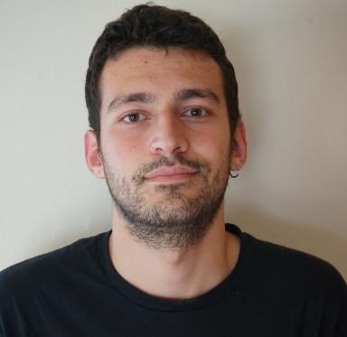 Franco Terranova

Identifiants chercheurs

- IdHAL : franco-terranova
- ORCID : 0009-0001-6989-2655
- cv.identifier.google scholar : uG7VFVUAAAAJ

Présentation

Hello! I’m Franco Terranova, currently a Ph.D. Student focusing on Deep Reinforcement Learning for Cyber-Attack Paths Discovery at the Université de Lorraine/LORIA.I have a Master’s Degree in Artificial Intelligence and Data Engineering, and a Bachelor’s Degree in Computer Engineering from the University of Pisa.I have previously interned for the European Space Agency (ESA) and the Fermi National Accelerator Laboratory (Fermilab) in several projects related to Deep Learning & Reinforcement Learning.

Publications

Communication dans un congrès (3)

Multi-Taxonomy Vulnerability Classification with Hierarchically Finetuned Language Models
Franco Terranova,Sana Rekbi,Abdelkader Lahmadi,Isabelle Chrisment
DIMVA 2026 - Conference on Detection of Intrusions and Malware and Vulnerability Assessment, Jul 2026, Chania, Crete, Greece
Communication dans un congrès
hal-05500820v2
Scalable and Generalizable RL Agents for Attack Path Discovery via Continuous Invariant Spaces
Franco Terranova,Abdelkader Lahmadi,Isabelle Chrisment
2025 28th International Symposium on Research in Attacks, Intrusions and Defenses (RAID), Oct 2025, Gold Coast, Australia. pp.440-457, ⟨10.1109/RAID67961.2025.00029⟩
Communication dans un congrès
hal-05182437v1
Leveraging Deep Reinforcement Learning for Cyber-Attack Paths Prediction: Formulation, Generalization, and Evaluation
Franco Terranova,Abdelkader Lahmadi,Isabelle Chrisment
The 27th International Symposium on Research in Attacks, Intrusions and Defenses (RAID 2024), Sep 2024, Padua, Italy. pp.1-16, ⟨10.1145/3678890.3678902⟩
Communication dans un congrès
hal-04662428v1

Poster de conférence (1)

Deep Reinforcement Learning for Automated Cyber-Attack Path Prediction in Communication Networks
Franco Terranova,Abdelkader Lahmadi,Isabelle Chrisment
Geilo Winter School 2024 - Graphs and Applications, Jan 2024, Geilo, Norway
Poster de conférence
hal-04462876v1

Pré-publication, Document de travail (1)

Projecting Latent RL Actions: Towards Generalizable and Scalable Graph Combinatorial Optimization
Franco Terranova,Guillermo Bernardez,Albert Cabellos-Aparicio,Nina Miolane,Abdelkader Lahmadi
2026
Pré-publication, Document de travail
hal-05620445v1

Logiciel (1)

Continuous CyberBattleSim
Franco Terranova,Abdelkader Lahmadi,Isabelle Chrisment
2025, ⟨swh:1:dir:0b32c22ea0771c26604e38728ab090df6469c4aa;origin=https://github.com/terranovafr/C-CyberBattleSim;visit=swh:1:snp:bc5aa14f7d947bec6111c51264e58ec506eeedac;anchor=swh:1:rev:7374c32b6711bb0e9b6d5fcd94d4eacc034c07cb⟩
Logiciel
hal-05194047v1

