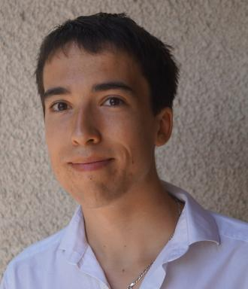 Francois Lamothe Chercheur Postdoctoral au LIMOS

Identifiants chercheurs

- IdHAL : francois-lamothe
- ORCID : 0000-0002-1332-9206
- arXiv : lamothe_f_1

Présentation

I am a researcher in operations research and optimization. I obtained my PhD from ISAE-Supaéro (Toulouse), where I worked on the unsplittable flow problem with applications to satellite communication networks. I then held several postdoctoral positions at CIRRELT (Montreal), LAAS-CNRS (Toulouse), and LIMOS (Clermont-Ferrand).
My research mainly focuses on mixed-integer linear programming, combinatorial optimization, with applications to networks, transportation, and sustainable systems. I am particularly interested in decomposition methods, polyhedral approaches, and the use of concepts from cooperative game theory such as the Shapley value. More broadly, I aim to connect optimization methods with societal and environmental challenges.
Here is my Google Scholar.

Publications

Article dans une revue (5)

On the integration of Dantzig-Wolfe and Fenchel decompositions via directional normalizations
François Lamothe,Alain Haït,Emmanuel Rachelson,Claudio Contardo,Bernard Gendron
EURO Journal on Computational Optimization, 2025, ⟨10.48550/arXiv.2303.15573⟩
Article dans une revue
hal-04875156v2
Rethinking LEO Constellations Routing
Paul Grislain,Alexia Auddino,Anna Barraqué,François Lamothe,Oana Hotescuet al.
International Journal of Satellite Communications and Networking, 2024, Special Issue ASMS/SPSC 2022, ⟨10.1002/sat.1514⟩
Article dans une revue
hal-04505620v1
Tilted inequalities and facets of the set covering polytope: A theoretical analysis
François Lamothe,Claudio Contardo,Matthieu Gruson
Discrete Applied Mathematics, 2024, 357, pp.143-160. ⟨10.1016/j.dam.2024.06.004⟩
Article dans une revue
hal-04874698v1
Dynamic unsplittable flows with path-change penalties: New formulations and solution schemes for large instances
François Lamothe,Emmanuel Rachelson,Alain Haït,Cédric Baudoin,Jean-Baptiste Dupé
Computers and Operations Research, 2023, 152, pp.106154. ⟨10.1016/j.cor.2023.106154⟩
Article dans une revue (article de synthèse)
hal-04638005v1
Randomized rounding algorithms for large scale unsplittable flow problems
François Lamothe,Emmanuel Rachelson,Alain Haït,Cedric Baudoin,Jean-Baptiste Dupé
Journal of Heuristics, 2021, 27 (6), pp.1081-1110. ⟨10.1007/s10732-021-09478-w⟩
Article dans une revue
hal-04637969v1

Communication dans un congrès (1)

Rethinking LEO Constellations Routing with the Unsplittable Multi-Commodity Flows Problem
Paul Grislain,Nicolas Pelissier,François Lamothe,Oana Hotescu,Jérôme Lacanet al.
The 11th Advanced Satellite Multimedia Systems Conference, Sep 2022, Graz, Austria. ⟨10.1109/ASMS/SPSC55670.2022.9914743⟩
Communication dans un congrès
hal-03739313v1

Pré-publication, Document de travail (1)

Approximating the Shapley value with sampling : survey and new stratification techniques
François Lamothe,Sandra Ulrich Ngueveu
2025
Pré-publication, Document de travail
hal-04995993v1

