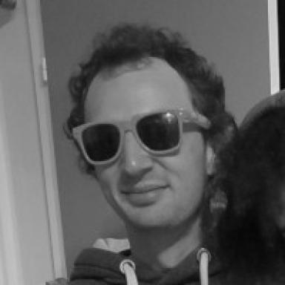 Gaétan Berthe Chercheur postdoctoral

Identifiants chercheurs

- IdHAL : gberthe
- ORCID : 0000-0003-0017-6922
- arXiv : berthe_g_1
- cv.identifier.google scholar : jR5XwK0AAAAJ

Publications

Pré-publication, Document de travail (3)

Pushing the frontiers of subexponential FPT time for Feedback Vertex Set
Gaétan Berthe,Marin Bougeret,Daniel Gonçalves,Jean-Florent Raymond
2025
Pré-publication, Document de travail (preprint/prepublication)
hal-05405556v1
Determining a graph from its reconfiguration graph
Gaétan Berthe,Caroline Brosse,Brian Hearn,Jan van Den Heuvel,Pierre Hoppenotet al.
2025
Pré-publication, Document de travail
hal-05293285v1
Kick the cliques
Gaétan Berthe,Marin Bougeret,Daniel Gonçalves,Jean-Florent Raymond
2024
Pré-publication, Document de travail
hal-04636118v1

Communication dans un congrès (6)

Pushing the Frontiers of Subexponential FPT Time for Feedback Vertex Set
Gaétan Berthe,Marin Bougeret,Daniel Gonçalves,Jean-Florent Raymond
ICALP 2025 - 52nd International Colloquium on Automata, Languages, and Programming, Jul 2025, Aarhus, Denmark. pp.26:1-26:15, ⟨10.4230/LIPIcs.ICALP.2025.26⟩
Communication dans un congrès
hal-05405560v1
Feedback Vertex Set for Pseudo-disk Graphs in Subexponential FPT Time
Gaétan Berthe,Marin Bougeret,Daniel Gonçalves,Jean-Florent Raymond
WG 2024 - 50th International Workshop on Graph-Theoretic Concepts in Computer Science, Jun 2024, Gozd Martuljek, Slovenia. pp.65-78, ⟨10.1007/978-3-031-75409-8_5⟩
Communication dans un congrès
lirmm-04938252v1
Kick the Cliques
Gaétan Berthe,Marin Bougeret,Daniel Gonçalves,Jean-Florent Raymond
IPEC 2024 - 19th International Symposium on Parameterized and Exact Computation, Sep 2024, Londres, United Kingdom. pp.13:1-13:17, ⟨10.4230/LIPIcs.IPEC.2024.13⟩
Communication dans un congrès
lirmm-04938282v1
Subexponential algorithms in geometric graphs via the subquadratic grid minor property: the role of local radius
Gaétan Berthe,Marin Bougeret,Daniel Gonçalves,Jean-Florent Raymond
SWAT 2024 - 19th Scandinavian Symposium and Workshops on Algorithm Theory, Jun 2024, Helsinki, Finland. pp.11:1-11:18, ⟨10.4230/LIPIcs.SWAT.2024.11⟩
Communication dans un congrès
hal-04149792v1
PACE Solver Description: Touiouidth
Gaétan Berthe,Yoann Coudert-Osmont,Alexander Dobler,Laure Morelle,Amadeus Reinaldet al.
IPEC 2023 - 18th International Symposium on Parameterized and Exact Computation, Sep 2023, Amsterdam, Netherlands. pp.38:1-38:4, ⟨10.4230/LIPIcs.IPEC.2023.38⟩
Communication dans un congrès
hal-04395895v1
Guiding Random Walks by Effective Resistance for Effective Node Embedding
Abderaouf Gacem,Mohammed Haddad,Hamida Seba,Gaétan Berthe,Michel Habib
ICPRAI 2022 - 3rd International Conference on Pattern Recognition and Artificial Intelligence, Jun 2022, Paris, France. pp.665-676, ⟨10.1007/978-3-031-09037-0_54⟩
Communication dans un congrès
hal-03701161v1

Article dans une revue (1)

PACE solver description: DreyFVS
Gabriel Bathie,Gaétan Berthe,Yoann Coudert-Osmont,David Desobry,Amadeus Reinaldet al.
Leibniz International Proceedings in Informatics , 2022, ⟨10.4230/LIPIcs.IPEC.2022.31⟩
Article dans une revue
hal-03920659v1

